Text Online-Shops EN: milKit Tubeless Sealants
A sealant that is easy to handle and works longer.
The milKit tubeless sealant not only fulfils all the requirements of a modern sealant but also offers additional advantages: It always remains homogeneous, which considerably simplifies tubeless installation and increases the function and lifetime of the sealant in the tire. The sealant is water-based, which makes it easy to wash off. It can also be diluted with water if necessary.
The milKit sealant is convincing in every aspect:
- The combination of synthetic latex and microfibers lead to exceptional performance.
- No ammonia, non-corrosive, non-allergenic
- Can be used in road, gravel and MTB tires and repairs holes and cuts up to six mm
- Remains liquid longer, dries evenly, doesn't ball-up and leaves no rubber balls behind
- Can be easily rinsed-off and can be diluted with water if necessary
- CO₂-compatible and works from -20 to +50°C/-4 to 122°F
Recommended amounts of sealant:
- Road/Gravel: 30–60ml/1–2 oz
- MTB 26“: 60–80ml/2–2.7 oz
- MTB 27.5“: 80–100ml/2.7–3.4 oz
- MTB 29“: 100–120ml/3.4–4 oz
The milKit tubeless sealant is available in the following bottle sizes:
- 60ml/2oz
- 250ml/8 oz
- 500ml/17oz
- 1000ml/34oz

Pictures of the milKit tubeless sealant
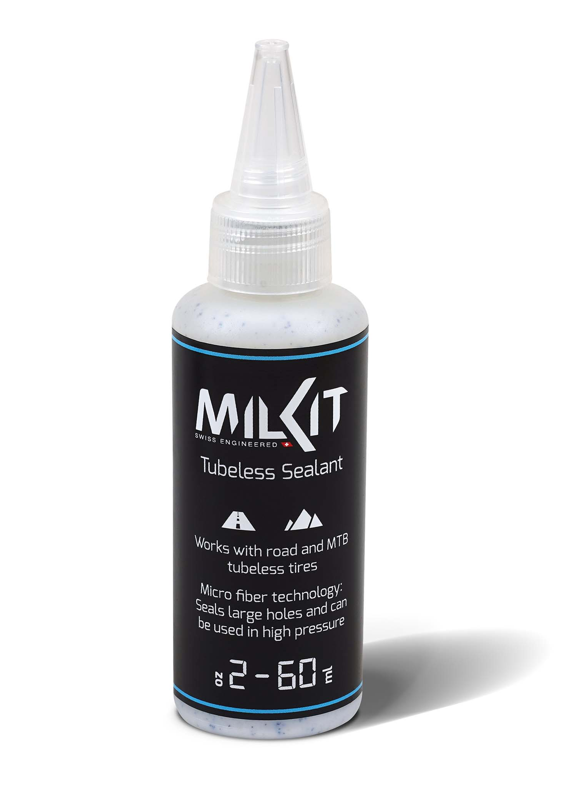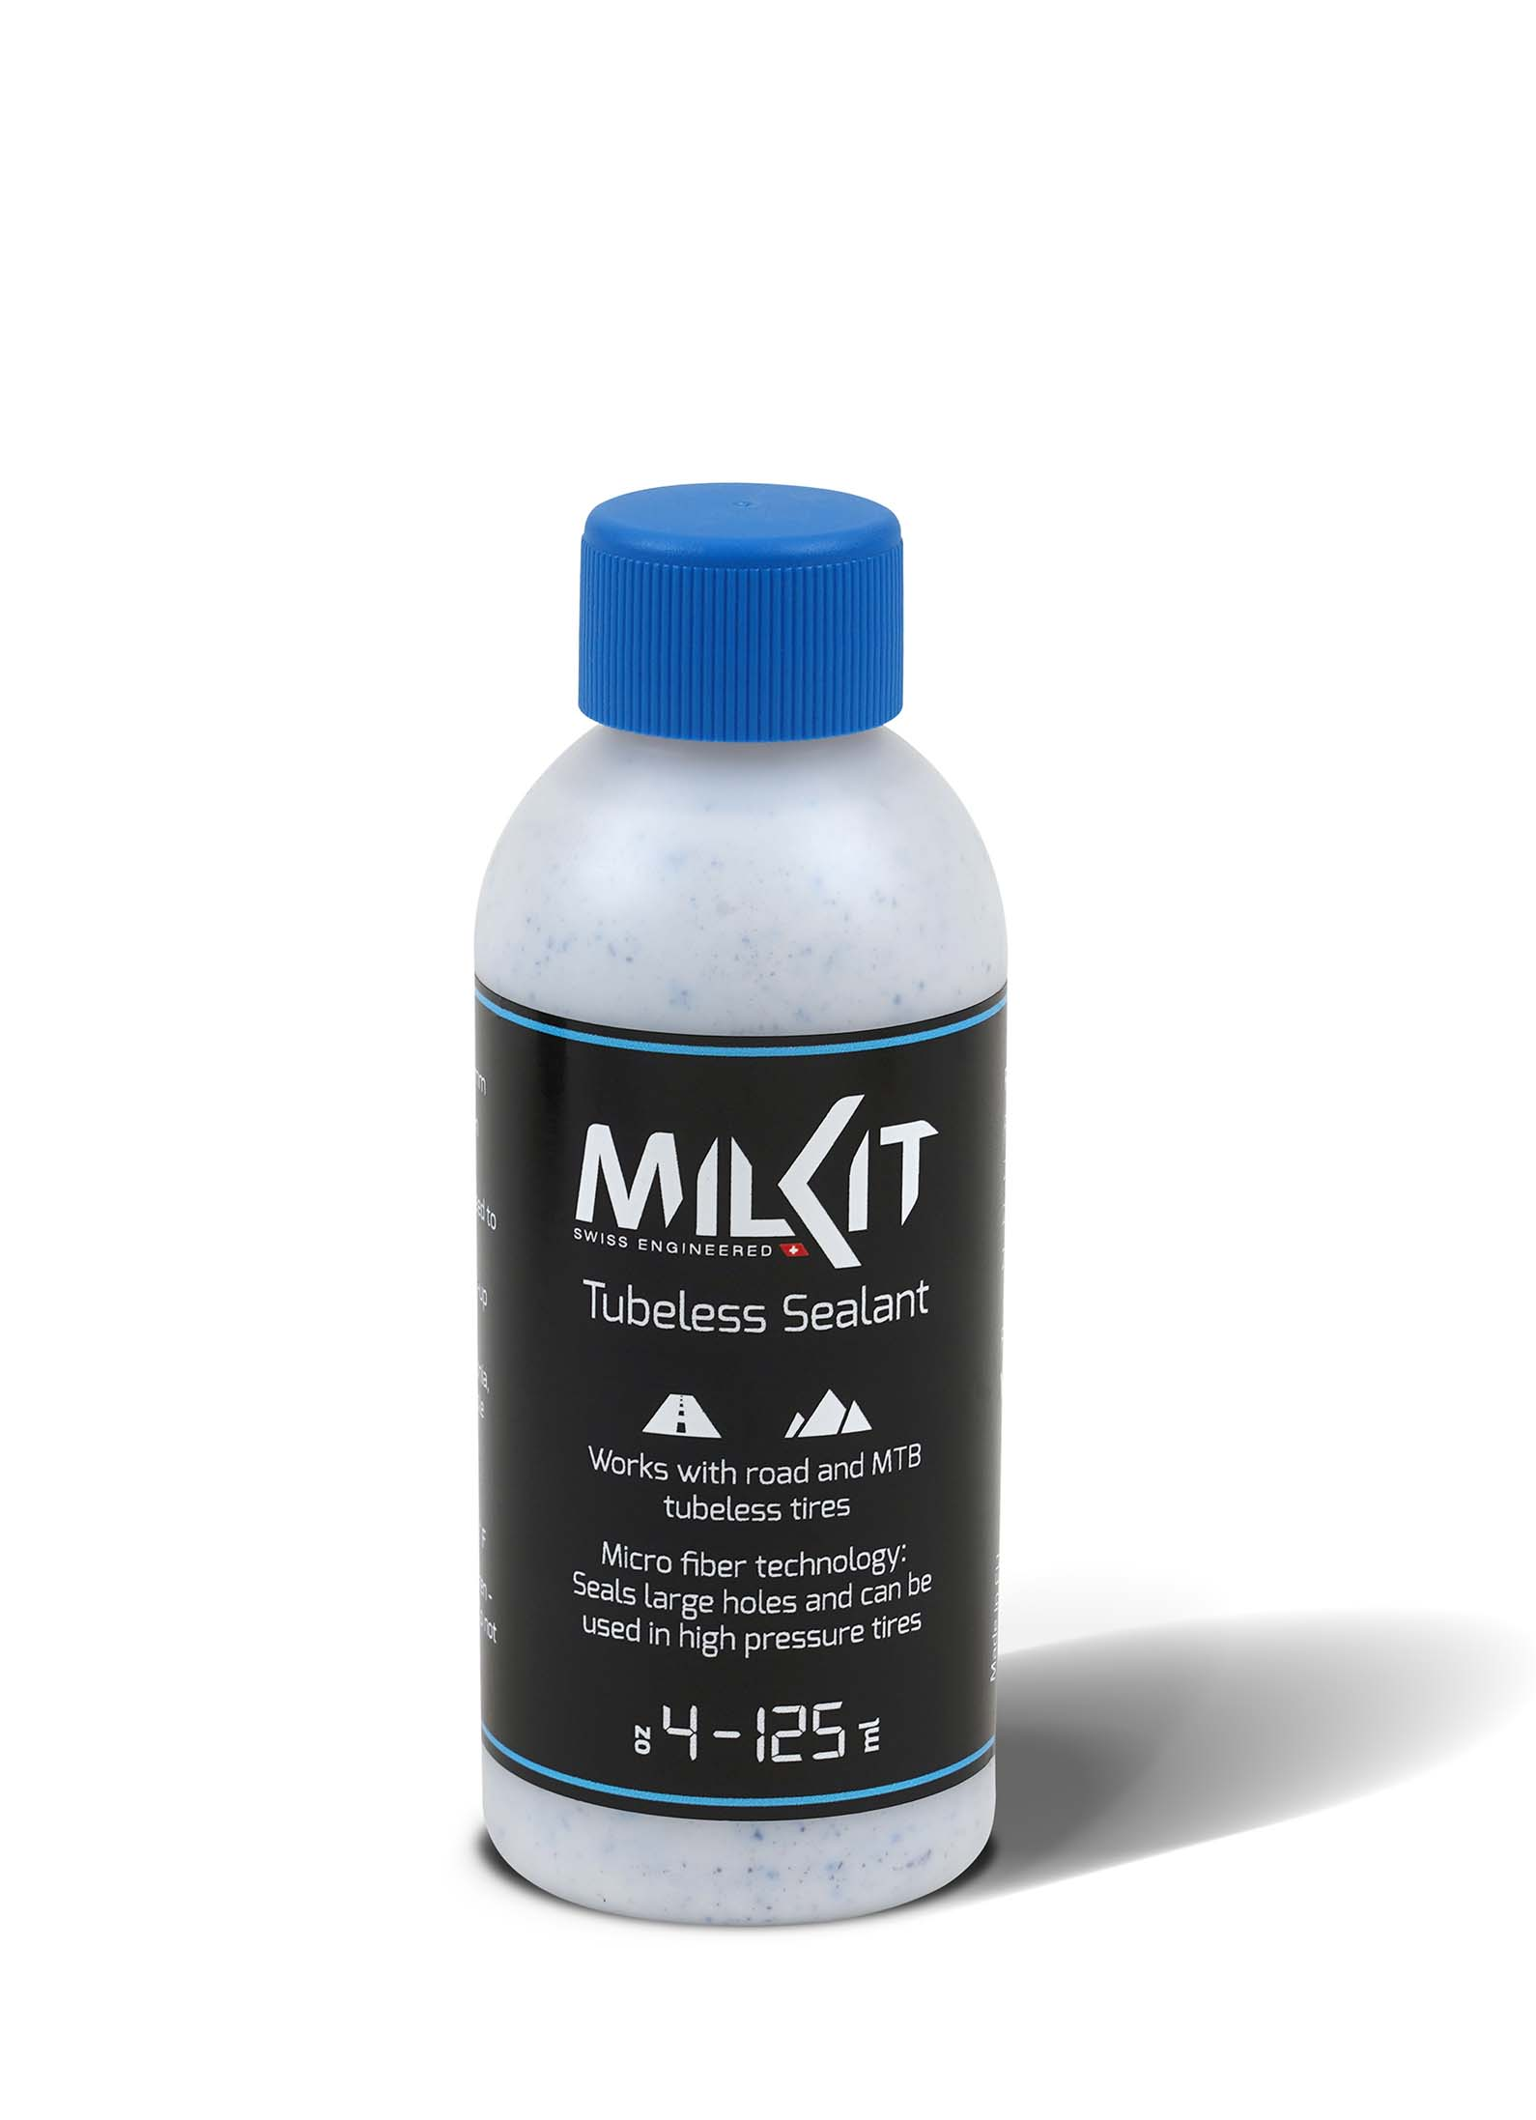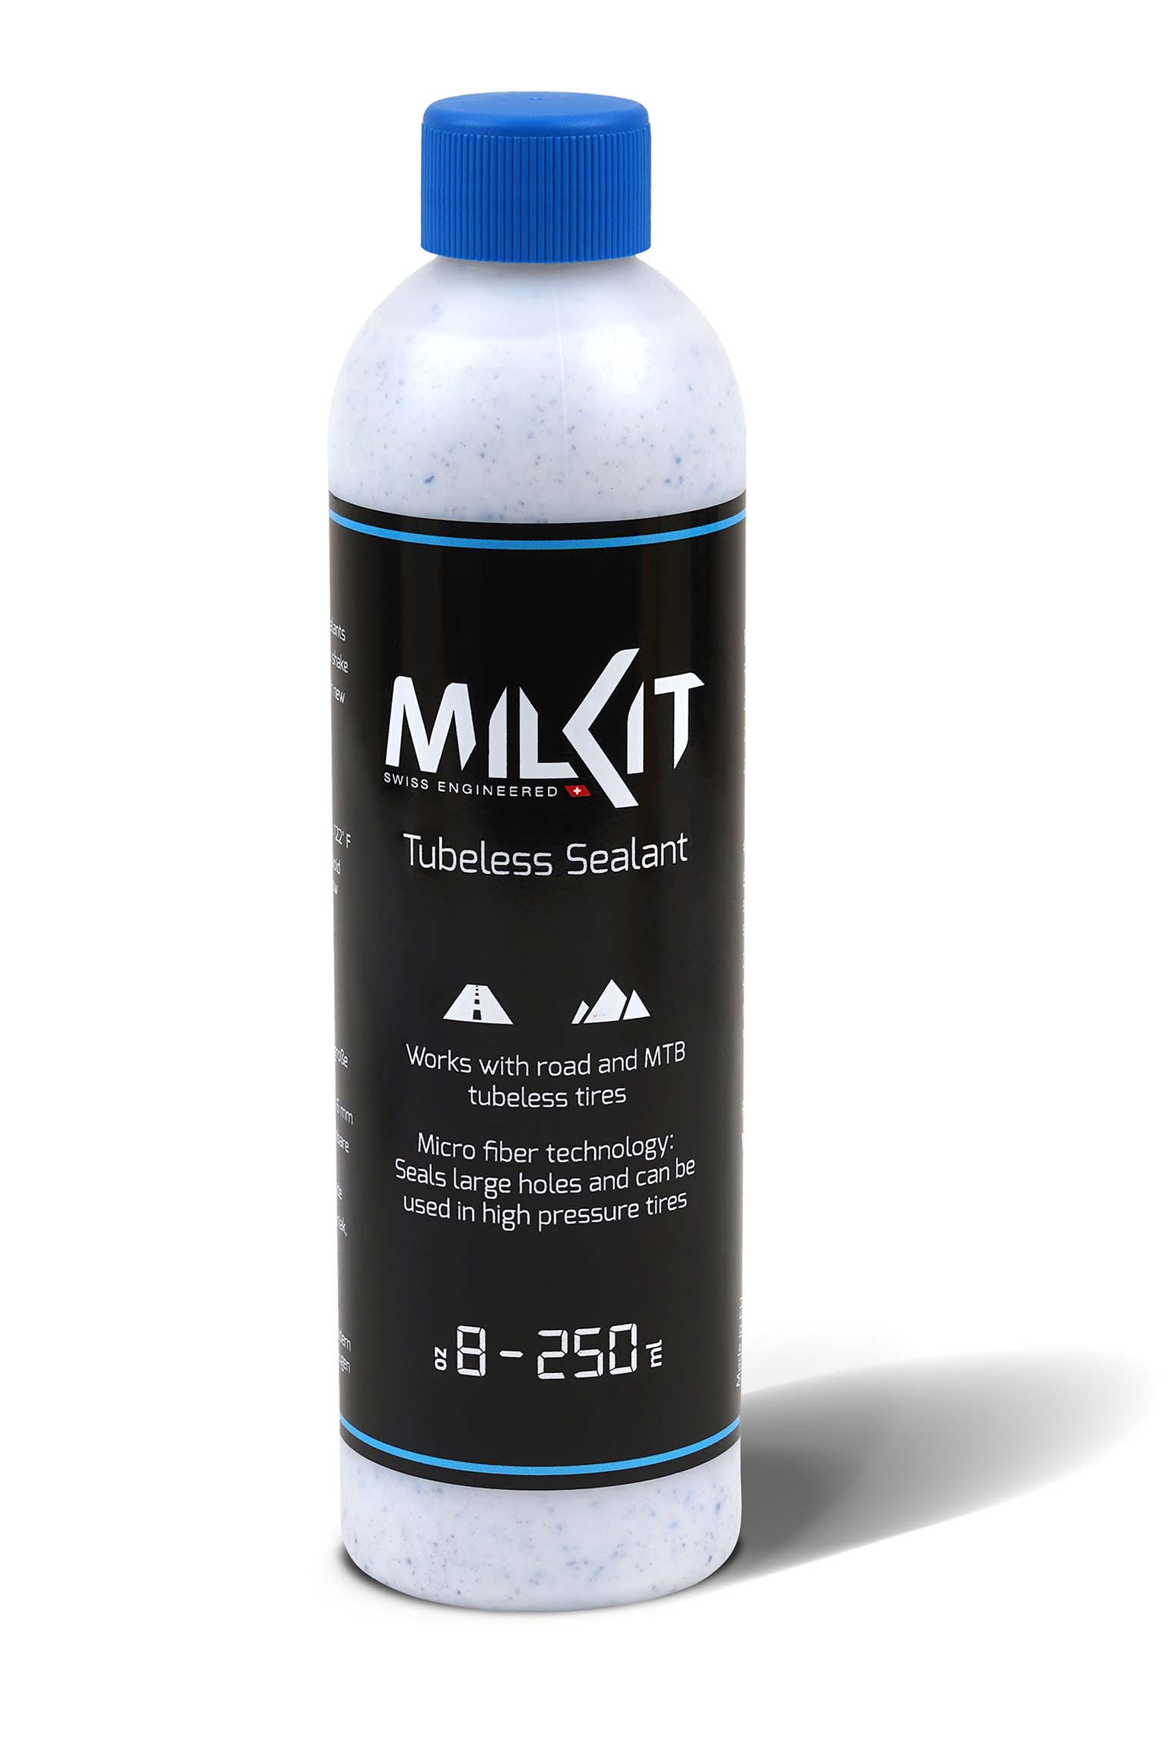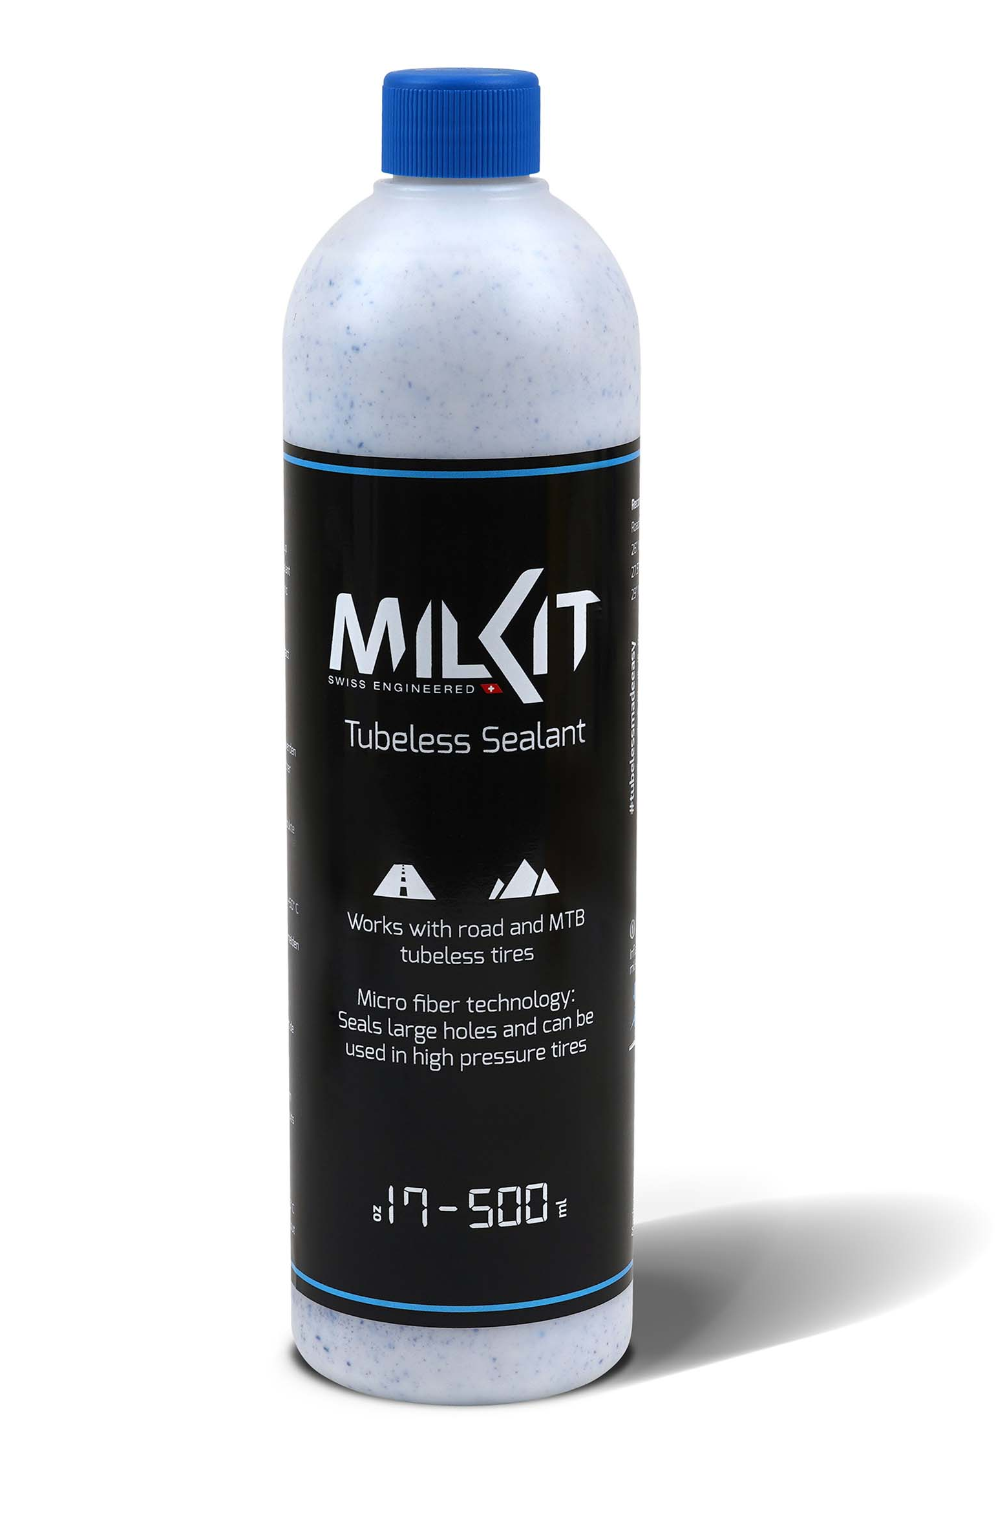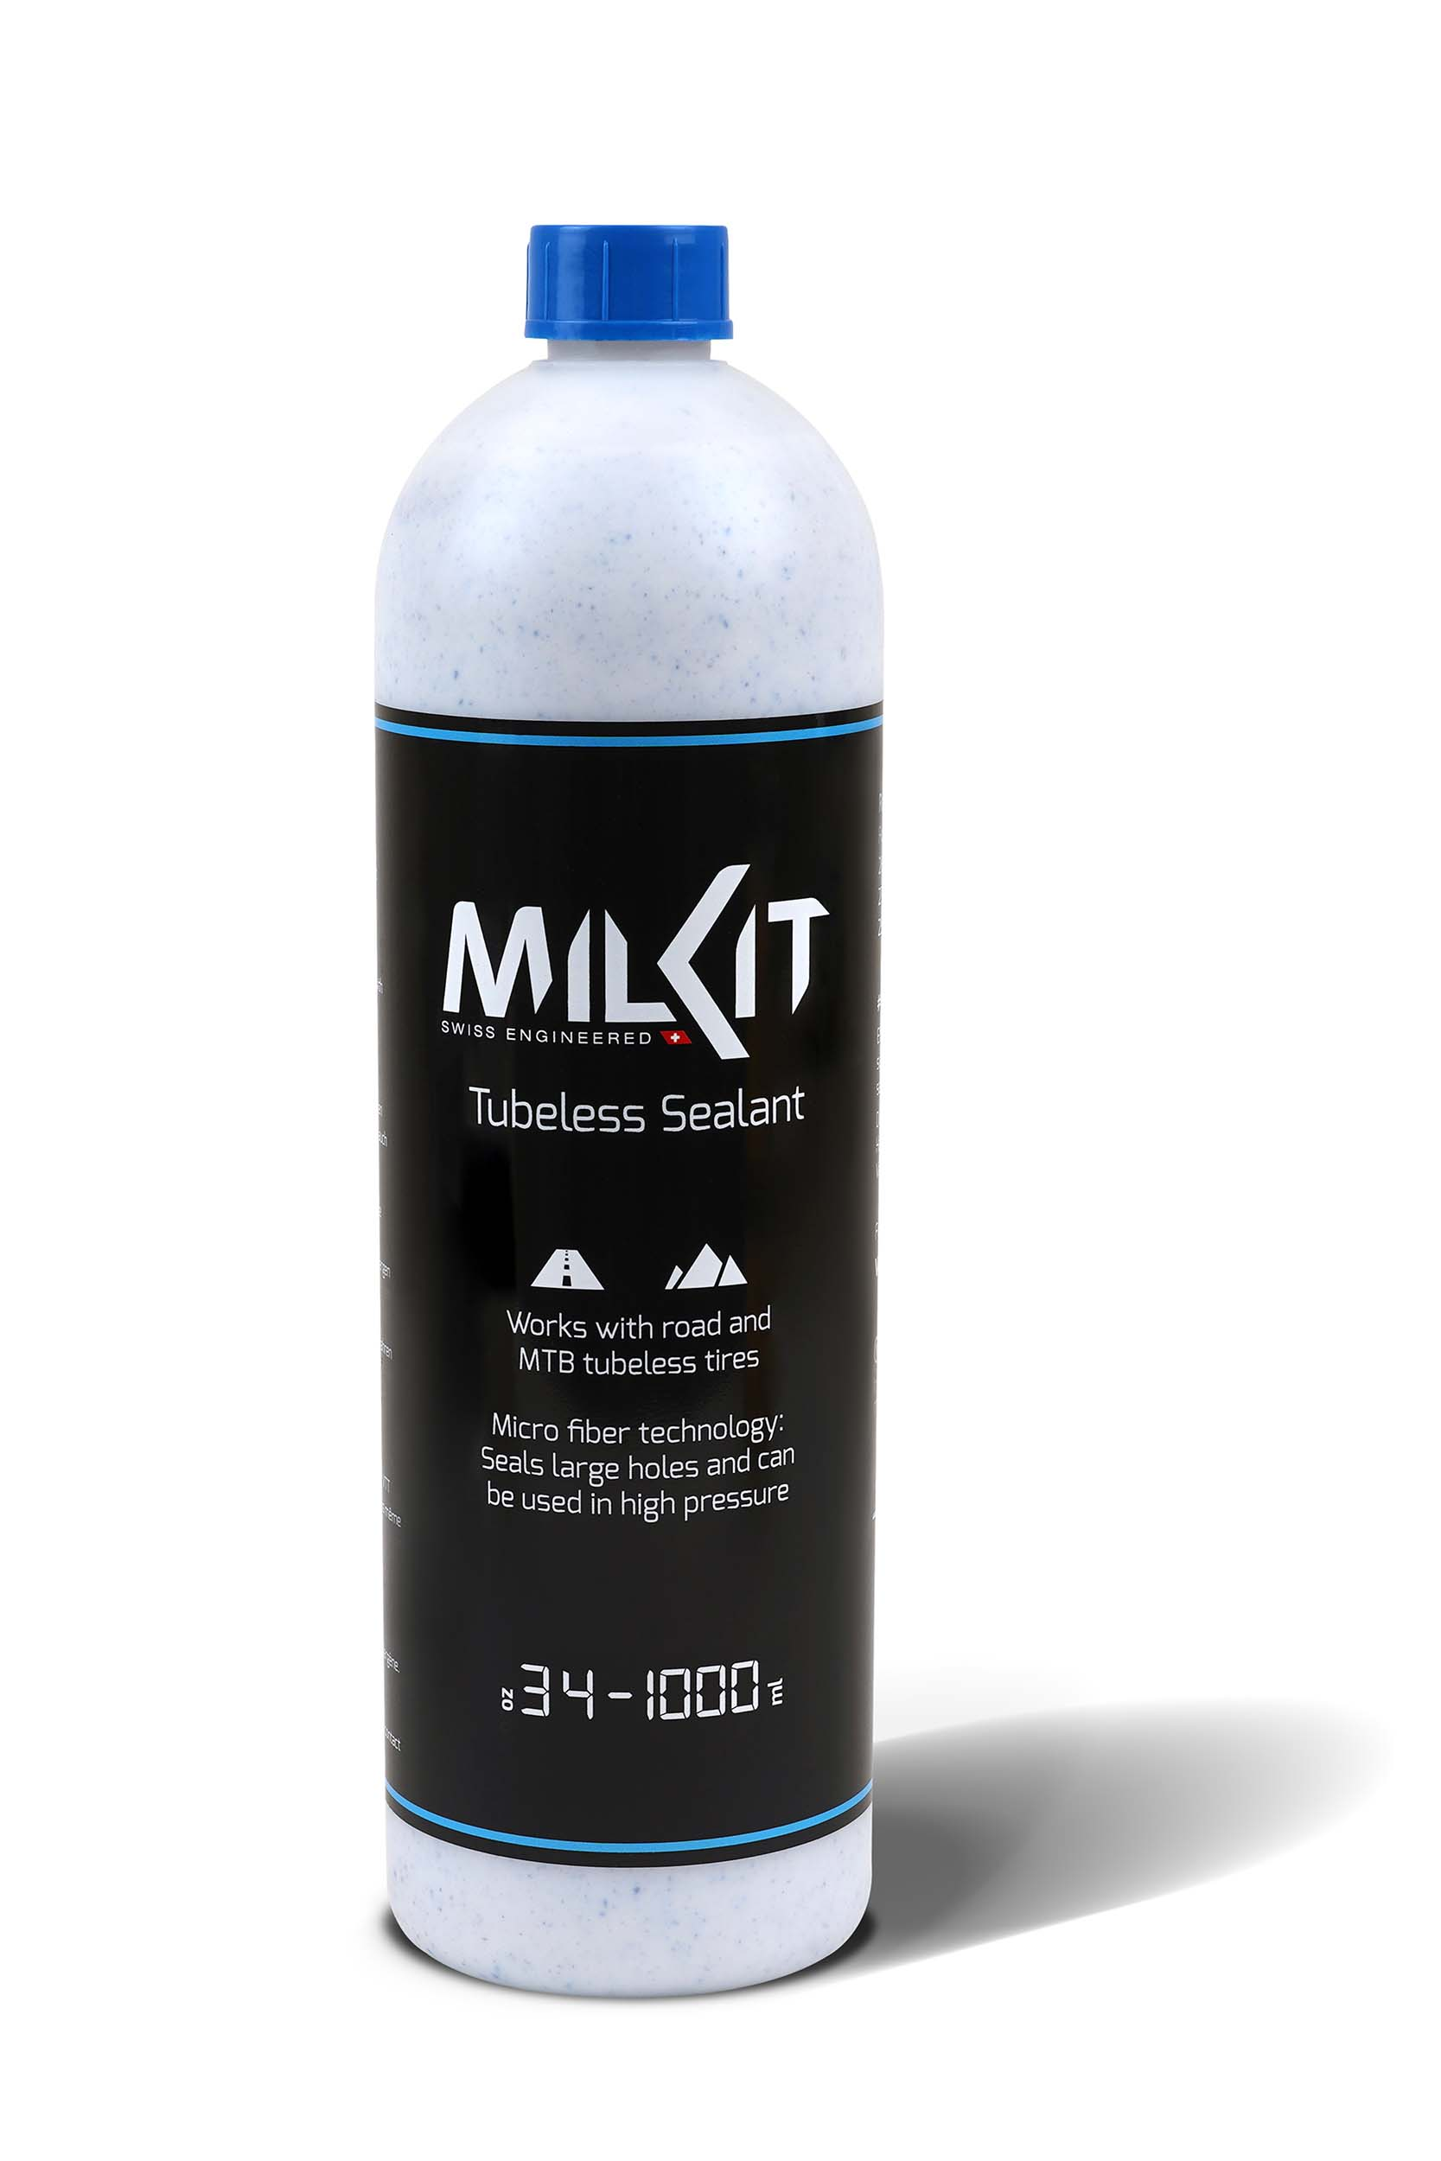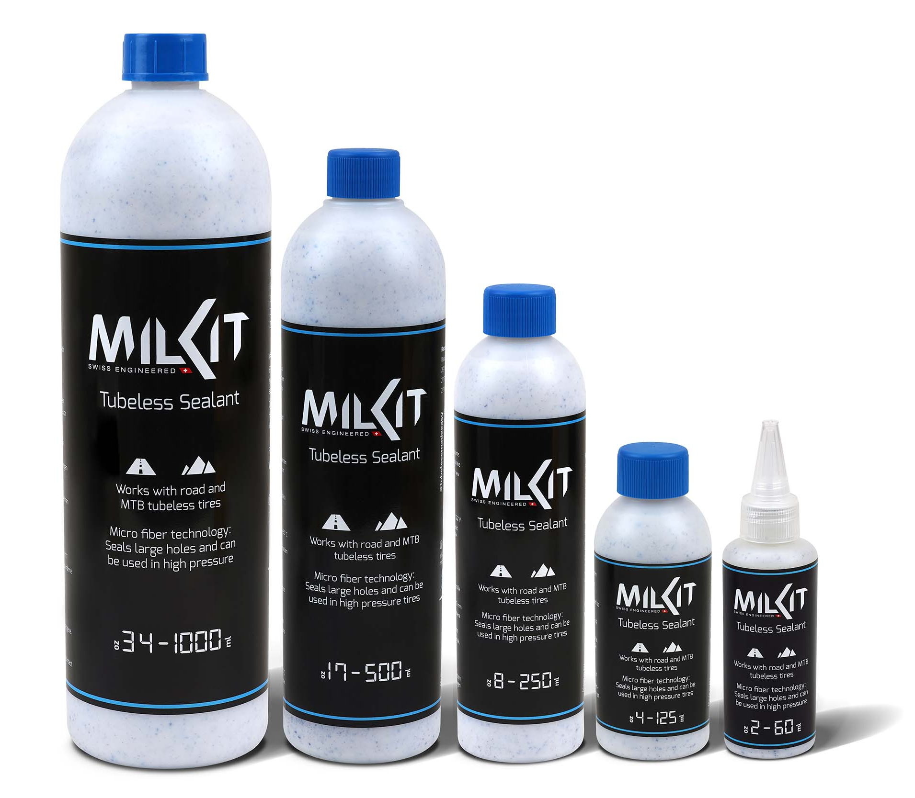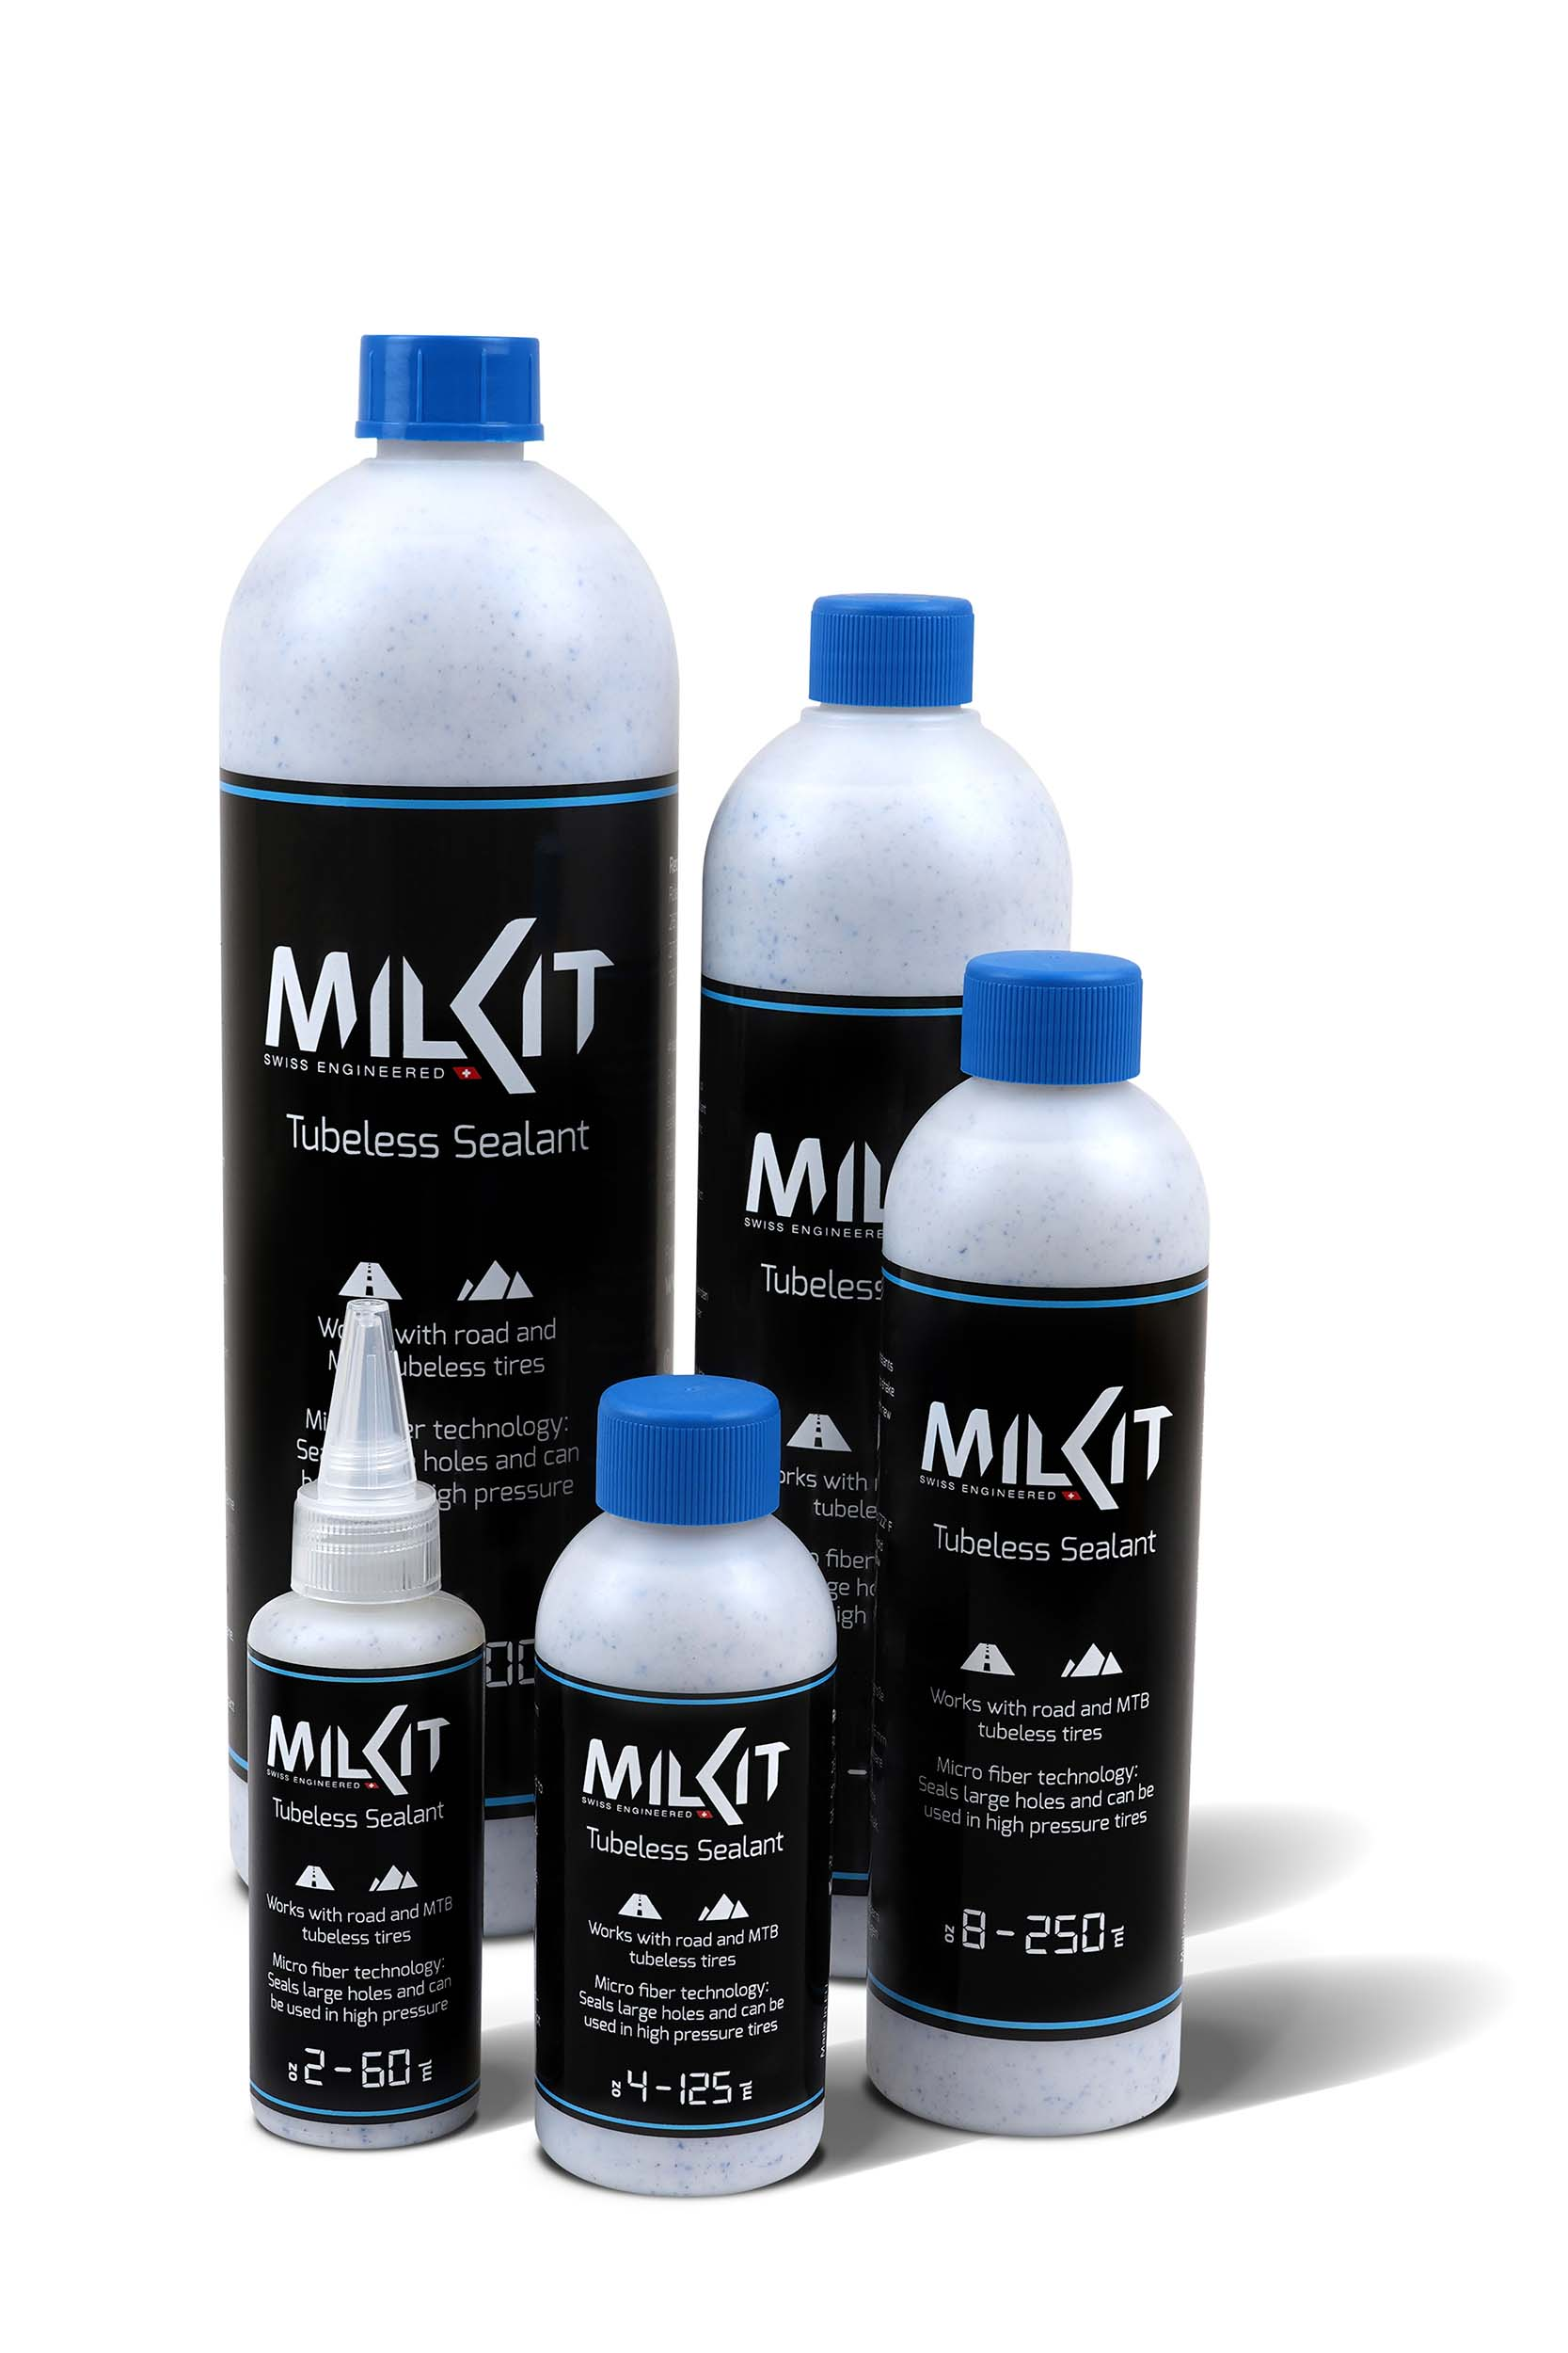

More pictures in high resolution: www.milKit.bike/media

