28 Mai 2019
Zürich, Switzerland

Do not release before 28 Mai 2019 9 AM BST / 3 AM CST!

New Innovative milKit Sealant
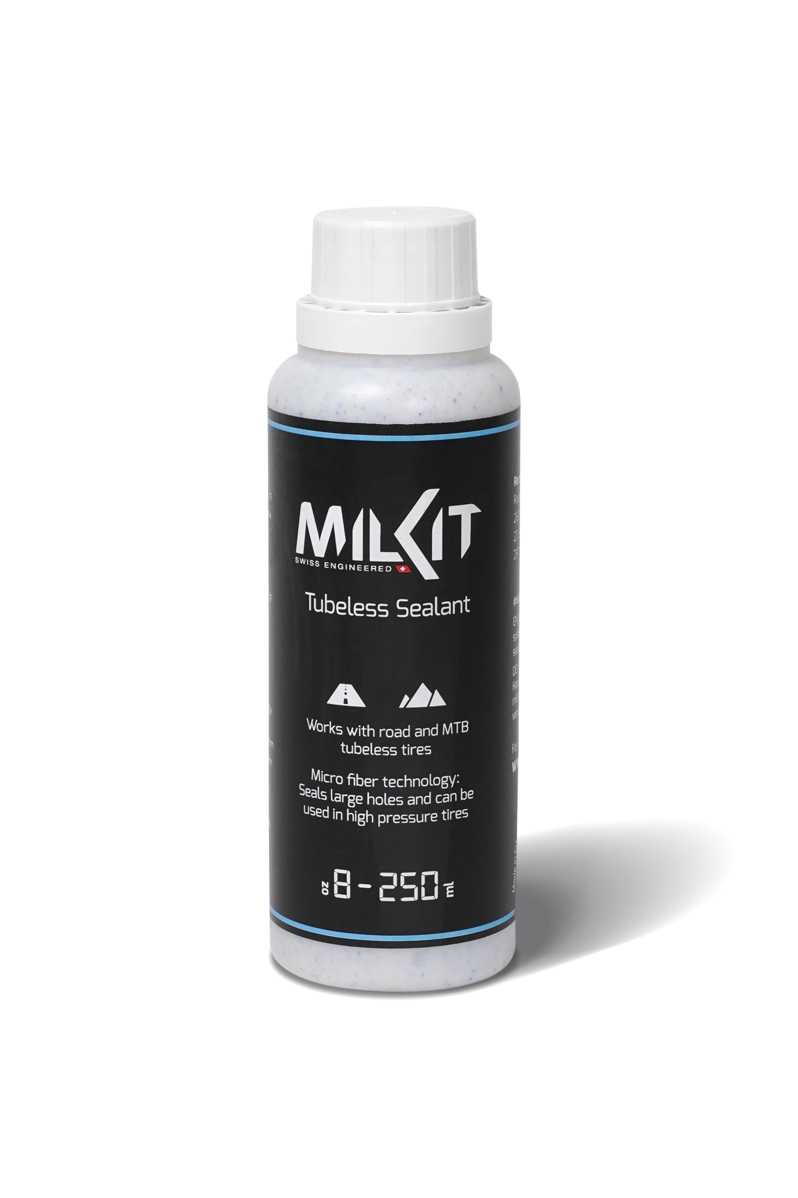
After the successful start with the innovative milKit valve system and the super-light and portable tubeless booster, the Swiss innovators from Sport Components Ltd are now launching their own sealant on the market - and they are once again setting the bar very high.
The new sealant fulfils what should be expected of a sealant today (but still isn't always the case) and contains no ammonia or other aggressive ingredients. It is therefore environmentally friendly, anti-allergenic and does not corrode rims and tires.
One of the main advantages of the new sealant is that it always remains a homogeneous liquid. The bottle therefore doesn't have to be shaken before use. Additionally, the microfibers, which play an important role in sealing large holes, are always ready everywhere and do not remain at the bottom of the bottle or tire. This means that the sealant has a significantly improved performance and fixes slits in the tire up to 6 mm in length. In the tire, the sealant does not decompose into rubber particles (rubber balls) and an aqueous residue, as it is known from many common products, but it dries evenly and slowly and therefore remains functional longer than comparable products.
The sealing effect of the microfibers also works very well at high pressure, making the sealant ideal for use in the increasingly popular road and gravel tubeless tires.
In order to guarantee that the inside of the tire is covered with sealant - even on the sidewalls - the milKit sealant adheres better to the tire wall than thin latex products. It can also be used in combination with CO2 cartridges and can be easily diluted with water and washed off if necessary. With an application range for temperatures between -20 to +50° C / -4 to 122° F, the milKit sealant is well prepared for even the most extreme tours.
The new sealant has already convinced several MTB pro teams in the world cup and is successfully used there. Since the beginning of May 2019, the product has now been available to consumers on the market in four different practical bottle sizes.
Pius Kobler, co-founder of Sport Components Ltd and responsible for the products, is pleased to announce the launch of the new sealant: "We have known for quite some time that we are on the right track with our sealant, as we know the weaknesses of previous products from our own experience. Now we are very pleased that we are starting out with our own sealant and we will be able to simplify the lives of our (tubeless) customers even further. Tubeless made easy!"

The advantages of the new milKit sealant in an overview:

- Synthetic latex: No ammonia, no horrible smell, no damage to rims and tires. Non-allergenic, non-hazardous.
- Stays in solution – no need to shake it up
- Dries evenly, no rubbery lumps to remove
- Lasts longer that other sealants
- Covers tire and side wall better than other sealants
- Fixes slits and holes up to 6 mm length
- CO2 compatible
- Works from -20 to +50° C / -4 to 122° F
- Microfiber technology: Stronger puncture sealing capability - even at high pressures (road tubeless)
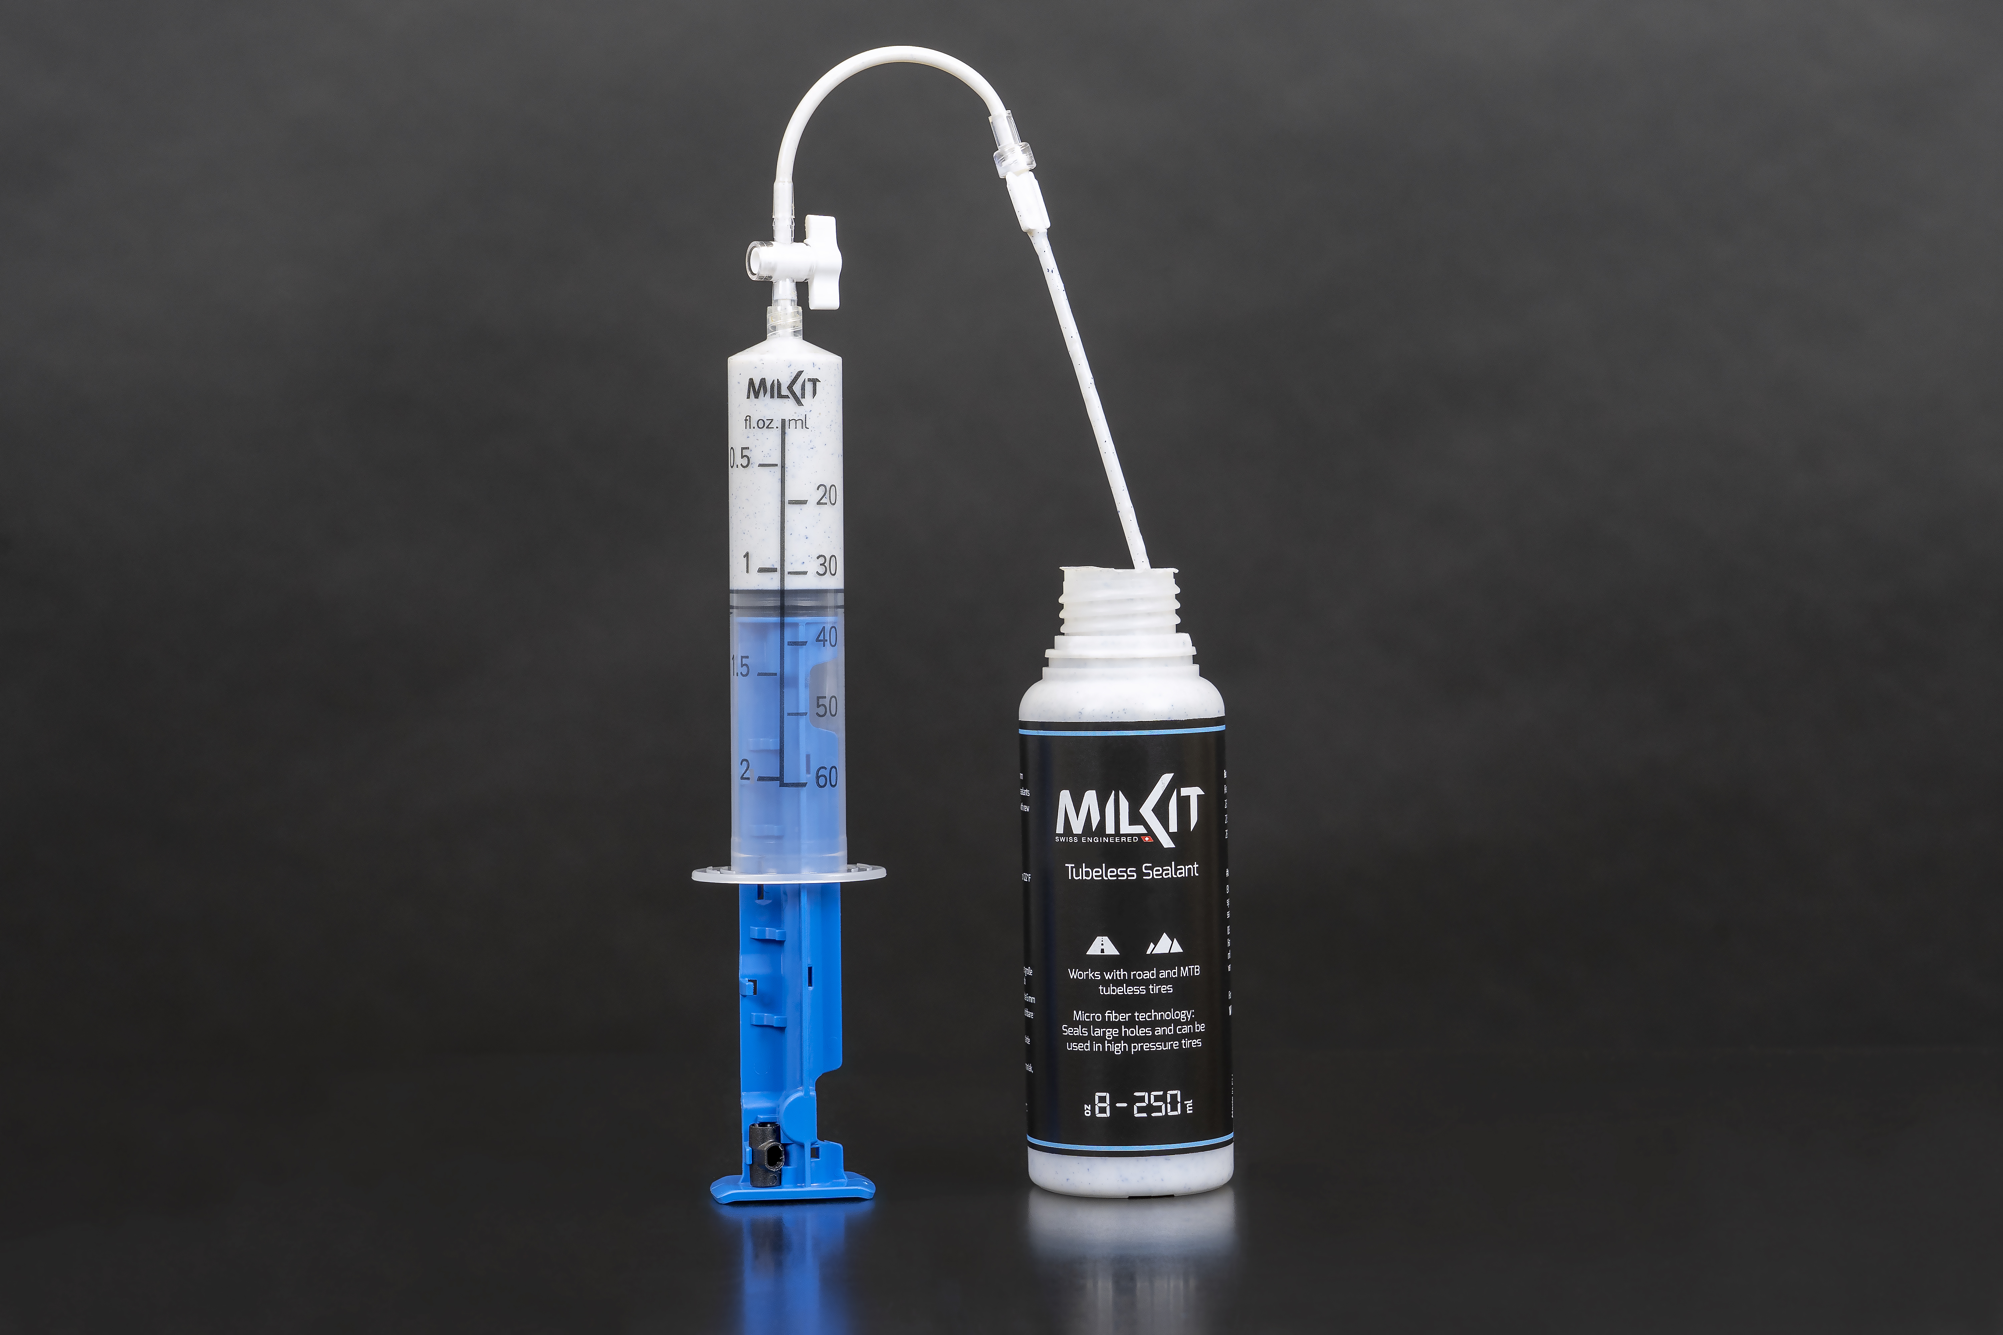
The milKit sealant is available in the following bottle sizes:
- milKit sealant 60ml / 2 oz @ 6.95 €
- milKit sealant 250ml / 8 oz @ 14.95 €
- milKit sealant 500ml / 17 oz @ 21.50 €
- milKit sealant 1000ml / 34 oz @ 33.95 €
milKit product family
- milKit compact, valve and syringe system – in four valve length options (new also 45mm): 55.95 – 59.95 €
- milKit valve pack, replacement valves in four valve lengths: 35 29.95 – 34.95 €
- milKit tubeless booster 0.6L / 20 oz and 1.0L / 34 oz: 47.95 - 49.95 €
The milKit sealant is now available through retailers and online stores. A list of milKit dealers can be found here.

About milKit
The milKit brand was created in 2015 by Swiss manufacturer Sport Components Ltd with the successful launch of the innovative tubeless valve system that makes the use and maintenance of tubeless tires easy. Product development engineer Pius Kobler and his team started the venture with the vision to develop innovative components for the bike and outdoor market.
Starting with milKit, Sport Components Ltd aims to become an international innovation leader for tubeless products and for the development of bicycle components at large.

For more information: milKit.bike
Do not release before 28 Mai 2019 9 AM BST / 3 AM CST!

