August 28th 2018
Zurich, Switzerland
DO NOT RELEASE UNTIL 4TH SEPTEMBER 2019

MILKIT TUBELESS BOOSTER WINS EUROBIKE AWARD
Though many tubeless riders, mechanics and shop owners already know the many advantages that the highly innovative milKit tubeless booster offers them, it is now official: The milKit booster is one of the winners of the Eurobike Award 2019!
The eco-friendliness of the booster, which replaces the throw-away CO2 cartridges, had the award jury convinced: "This practical accessory doubles as a tough water bottle and tubeless tire booster. A must for mountain bikers and a benefit for the environment too, since it saves on single-use carbon dioxide cartridges."
The Booster is a revolutionary tool that enables riders to inflate tubeless tires without the need for an air compressor. It solves an obvious challenge for cyclists who want to use tubeless tires, many of whom hesitate to go tubeless because of the more difficult installation of tubeless tires. Depending on the rim and tire combination, inflating tubeless tires with a floor pump can be impossible, as the air escapes between the tire and the rim. Professional mechanics typically have a compressor on hand to provide the necessary boost of air to seat tubeless tires on the rim, but for consumers, a compressor is a big expense. The milKit Booster answers the question of how to compress and deliver air to a tubeless tire, and does so by means of a lightweight, robust and inexpensive design.
Combined with milKit’s well-designed valves and fittings, an aluminum bottle makes the basis of the Booster system, which works in three simple steps:
- Inflate the Booster with your bike pump
- Remove the valve core from your tubeless valves for more efficient air flow (Optional but recommended)
- Push the Booster onto the valve stem – done. Air stays in the tire without the valve core installed.
- Add sealant to the tire with the milKit syringe system – no more mess.
There are no hoses or additional valves to reduce air flow, making inflating tubeless tires with the milKit Booster more efficient than any other existing solution.
The milKit Booster was designed with mountain biking in mind, but it also performs on tubeless road, gravel and cyclocross tires as well. It is very lightweight, only 150 grams, and therefore an ideal companion to bring along on any length of ride or terrain, or to pack during travel or bikepacking. The option to use the Booster as a water bottle along with the provided cap has to be one of the coolest elements about this economical, 2-in-1 product.
The new 0.75L / 25 oz bottle is the ideal size for the bottle to fit into a bottle cage and is also large enough to be able to inflate even the most stubborn tires.
"A number of tubeless users and bike mechanics approached us and said that they loved the milKit valve system and asked if we couldn't also find an easy solution to the one problem remaining with tubeless tires: inflating them without having to use a compressor," says Pius Kobler, co-founder and CTO at milKit. "This inspired us to develop the Booster.”
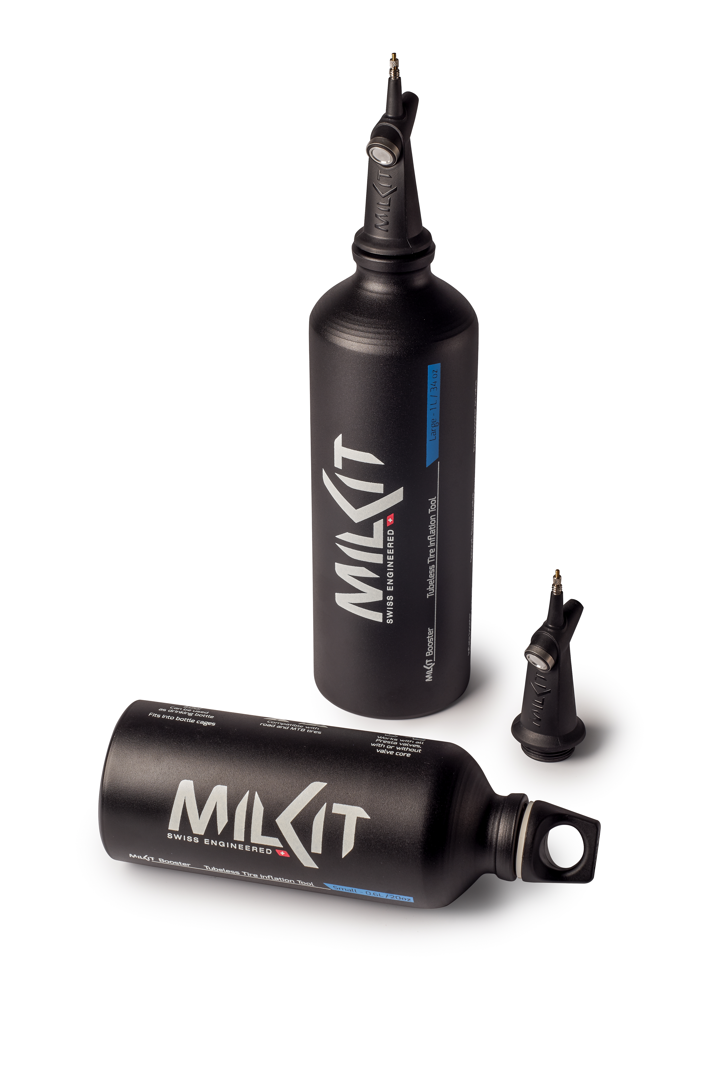
Booster 0.75 Liter / 25 oz @ $59.95
Booster 0.6 Liter / 20 oz @ $59.95

milKit Family of Products
- milKit Compact Tubeless Valve & Refill Kit
  - Four valve length versions from 35 to 75 mm @ $64.95
- milKit valve Pack
  - Four valve length versions from 35 to 75 mm @ $34.95
- New innovative milKit tubeless sealant
  - Four bottle sizes from 60ml / 2 oz up to 1000 ml / 34 oz @ $7.95 to $38.95
The milKit Booster is available now at independent bicycle dealers, and online retailers found here.

About milKit
The milKit brand was created in 2015 by Swiss manufacturer, Sport Components Limited, with the successful launch of the innovative tubeless valve system that makes the use and maintenance of tubeless tires easy. Product development engineer Pius Kobler and his team started the venture with the vision to develop innovative components for the bike and outdoor market.
Starting with milKit, Sport Components Limited aims to become an international innovation leader for tubeless products and for the development of bicycle components at large. We developed milKit, a kit that allows to measure and refill sealant in tubeless bicycle tires without having to remove the tire or release the air pressure. The milKit Booster is their follow-up innovation, which further evidences the company’s commitment to improving the cycling and bike maintenance experience for all users.

For more information and images: milKit.bike/media

