Text Online-Shops EN: milKit Replacement Valves

Tubeless tire set-up without the worries, the mess and the clogged-up valves
The revolutionary milKit tubeless valve system makes the maintenance of tubeless tires quick, easy and clean.
- Measure, change and top up sealant while maintaining air pressure in the tire.
- Close the rubber flaps at the bottom of the valves to prevent the sealant from clogging the valve
- Easy tubeless installation: milKit valves maintain the air in the tire without the valve core installed - you can add the sealant after inflating the tire without making a mess.
Swiss-engineered and made in Germany, the product is convincing because of its high-quality and lightweight aluminium valves as well as the elegant design with intelligent detailing.
The valves fit into all common rims, including that of road, gravel and MTB tubeless wheels.
More information and videos can be found on www.milKit.bike
milKit Replacement Valves contain the following:
- 2x milKit aluminium tubeless valve
- 1x valve core tool
- 1x info leaflet
milKit products are available with 35mm, 45mm, 55mm and 75mm valve length.
.

Pictures of the milKit Replacement Valves

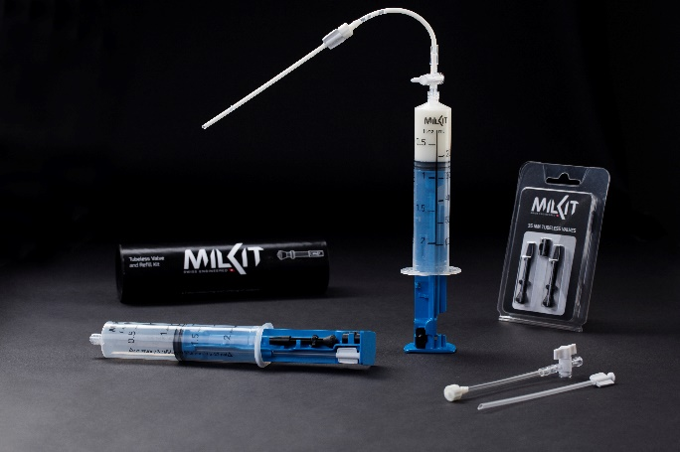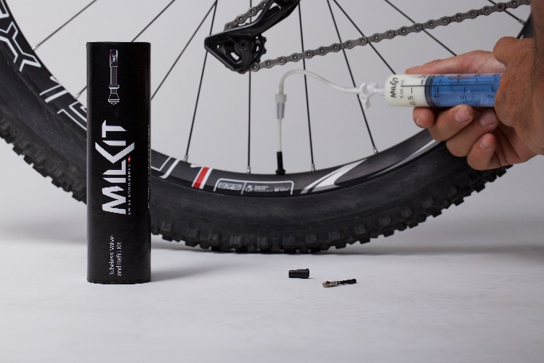

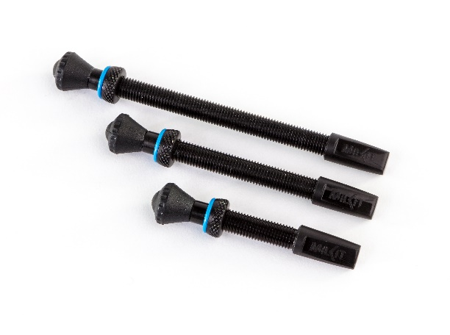
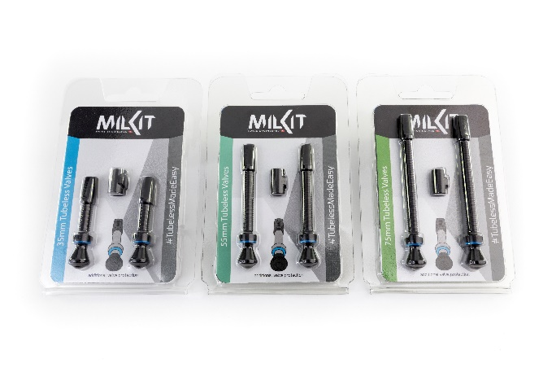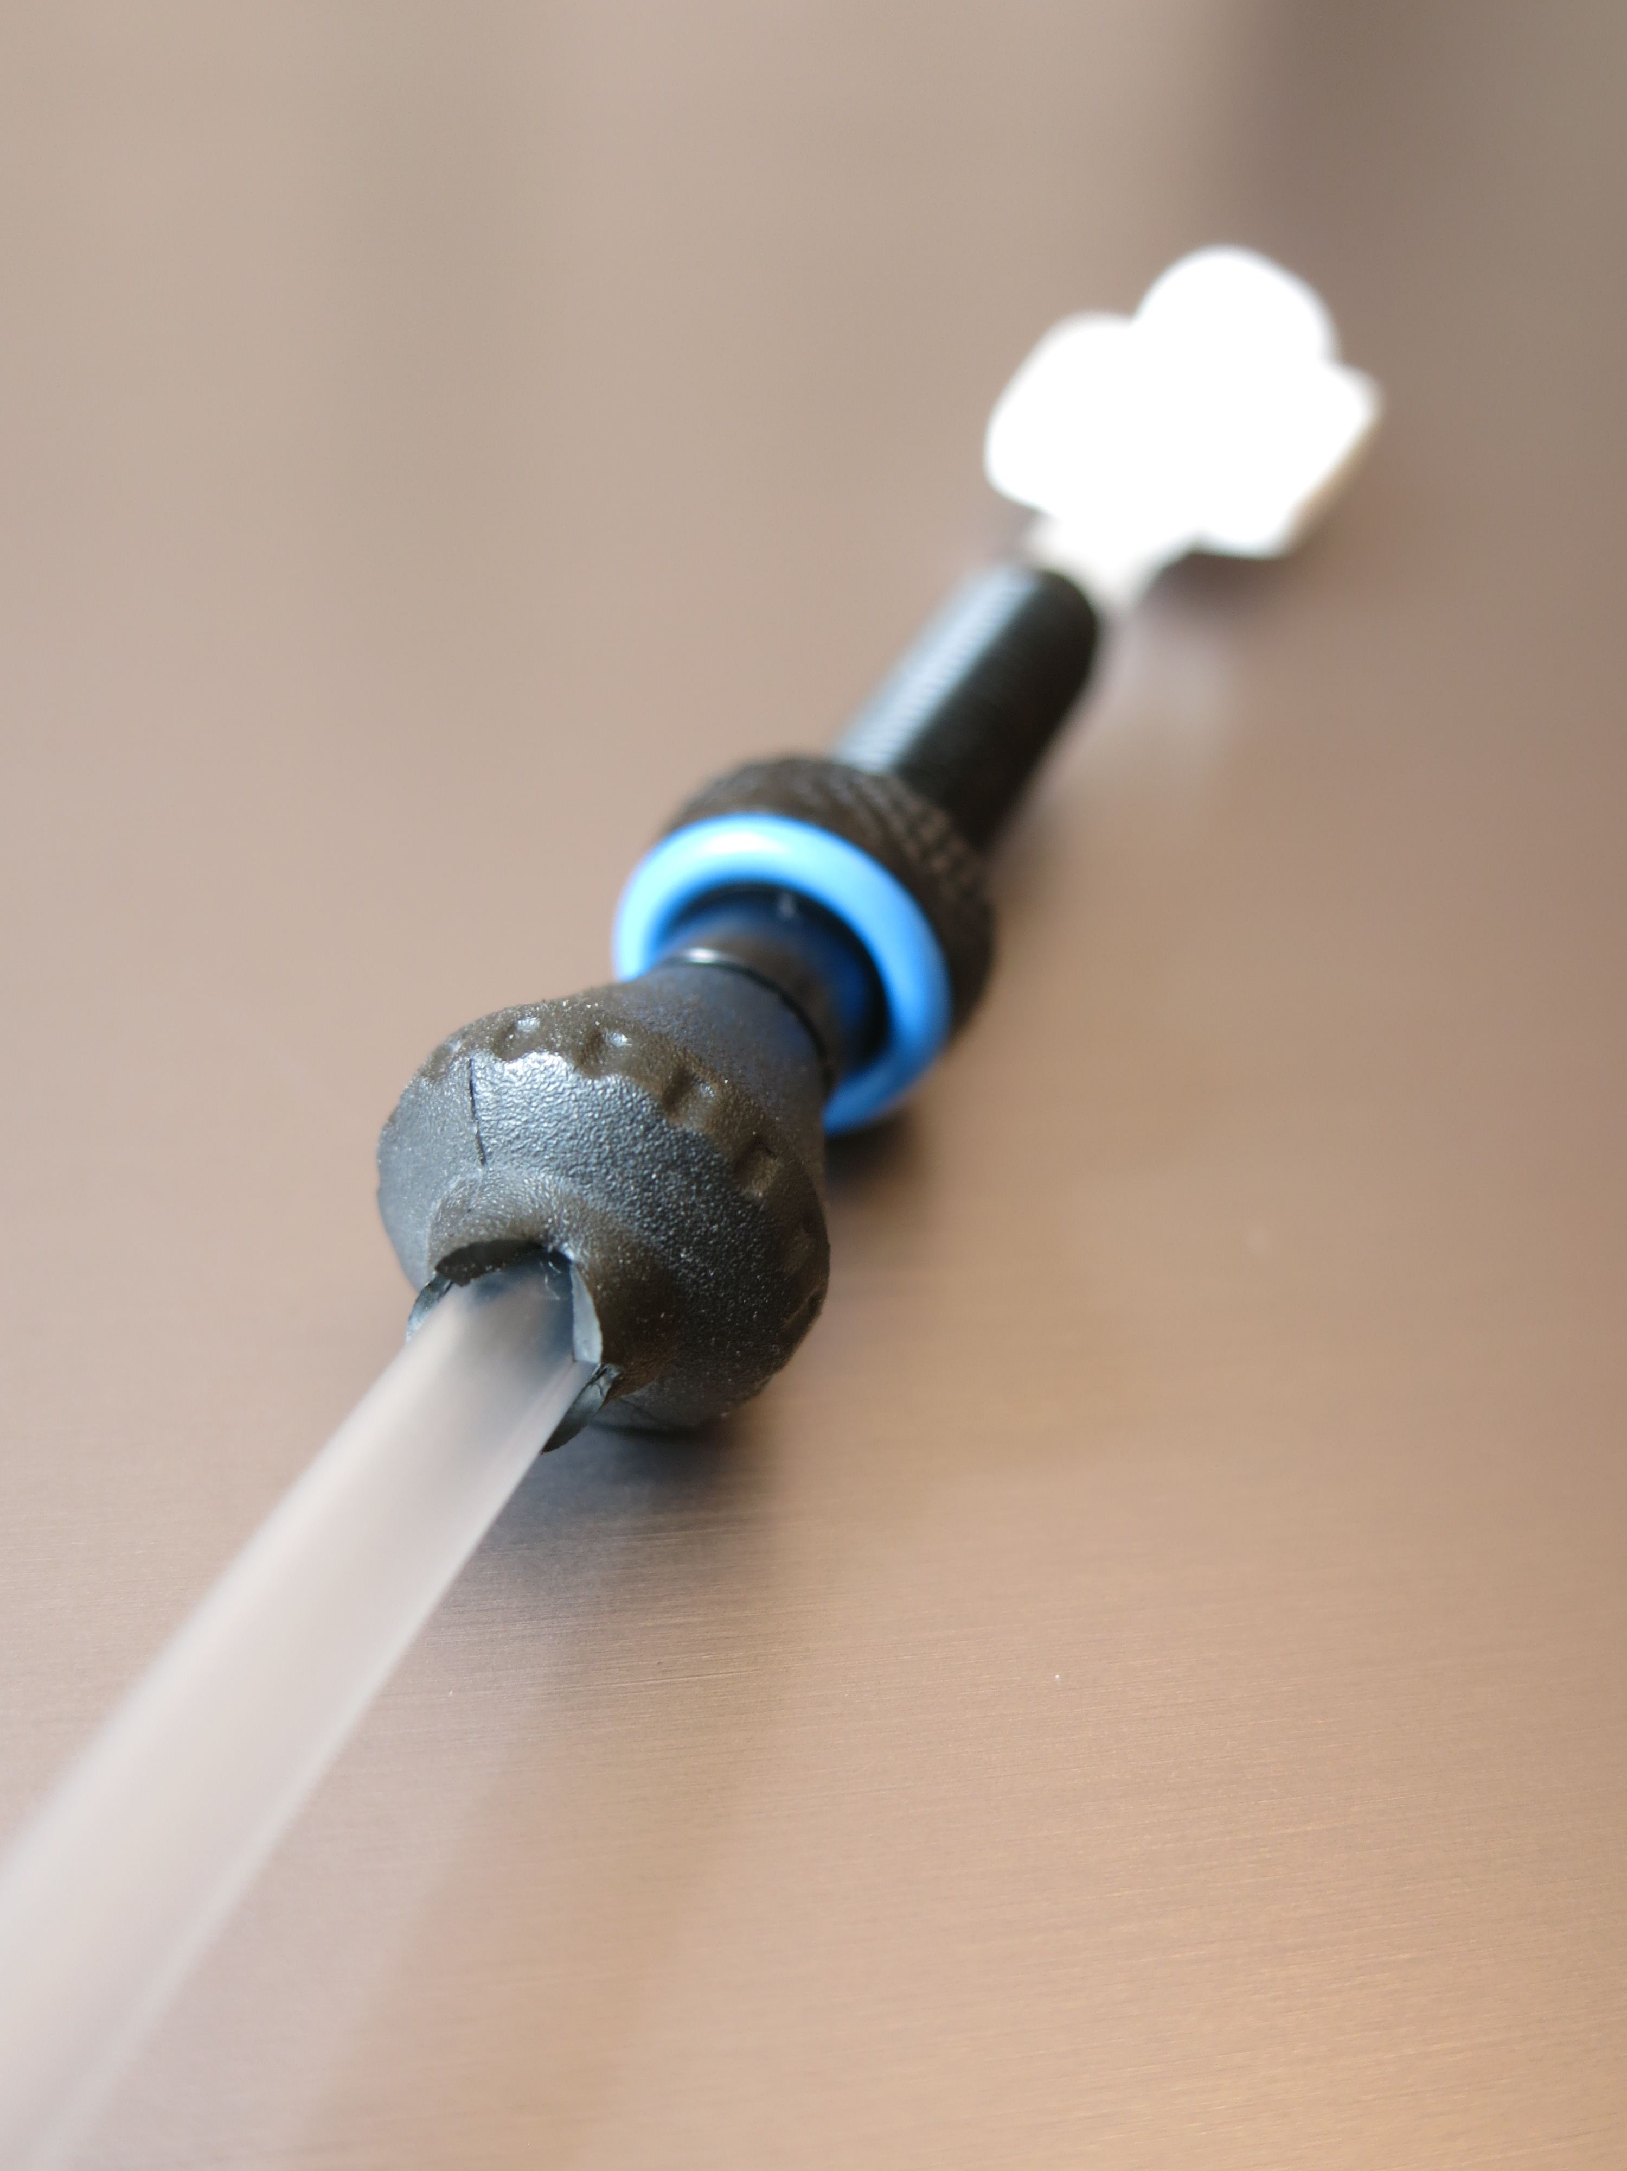

More pictures in high resolution: www.milKit.bike/media

