Text Online-Shops EN: milKit Tubeless Boosters Sized 0.6L/20 oz and 0.75L/25 oz
Are you looking for the easiest and quickest way to set your TL tires on your TL rim? milKit’s TL Booster is the award-winning solution.
The milKit tubeless specialists take the installation of tubeless tires to the next level with the milKit tubeless booster. You don't need to invest in a compressor nor do you have to buy a tubeless floor pump. The milKit Booster is exactly what you need to mount tubeless tires quickly and easily. The booster is also a faithful companion on rides and can be used as a drinking bottle.
The Eurobike Award winning milKit Booster is convincing for the following reasons:
- a very low weight (only 140 gr/5 oz)
- high efficiency (full air pressure right by the valve)
- ease of use (just press on the valve, done)
- its portability (can be used as drinking bottle in your bottle cage)
- great value
- it is environmentally friendly as it replaces CO2 cartridges
Using the milKit tubeless booster simplifies tubeless installation, especially in combination with the milKit valves:
- Install milKit valves into your rim
- Inflate the milKit booster with your bike pump
- Remove valve core for good air flow and press the booster on valve – BOOST!
- The milKit valves keep the air in the tire without the valve core installed. The sealant can be added after inflating the tire with the milKit syringe; it is absolutely mess free!
- Insert valve core and inflate the tire to full pressure
milKit Booster small includes the following:
- 1 x 0.6 L/20 oz aluminium bottle
- 1 x Booster head
- 1 x water bottle cap
- 1 x drawstring bag for Booster head
milKit Booster large includes the following:
- 1 x 0.75 L/25 oz aluminium bottle
- 1 x Booster head
- 1 x water bottle cap
- 1 x drawstring bag for Booster head

Pictures of the milKit Boosters
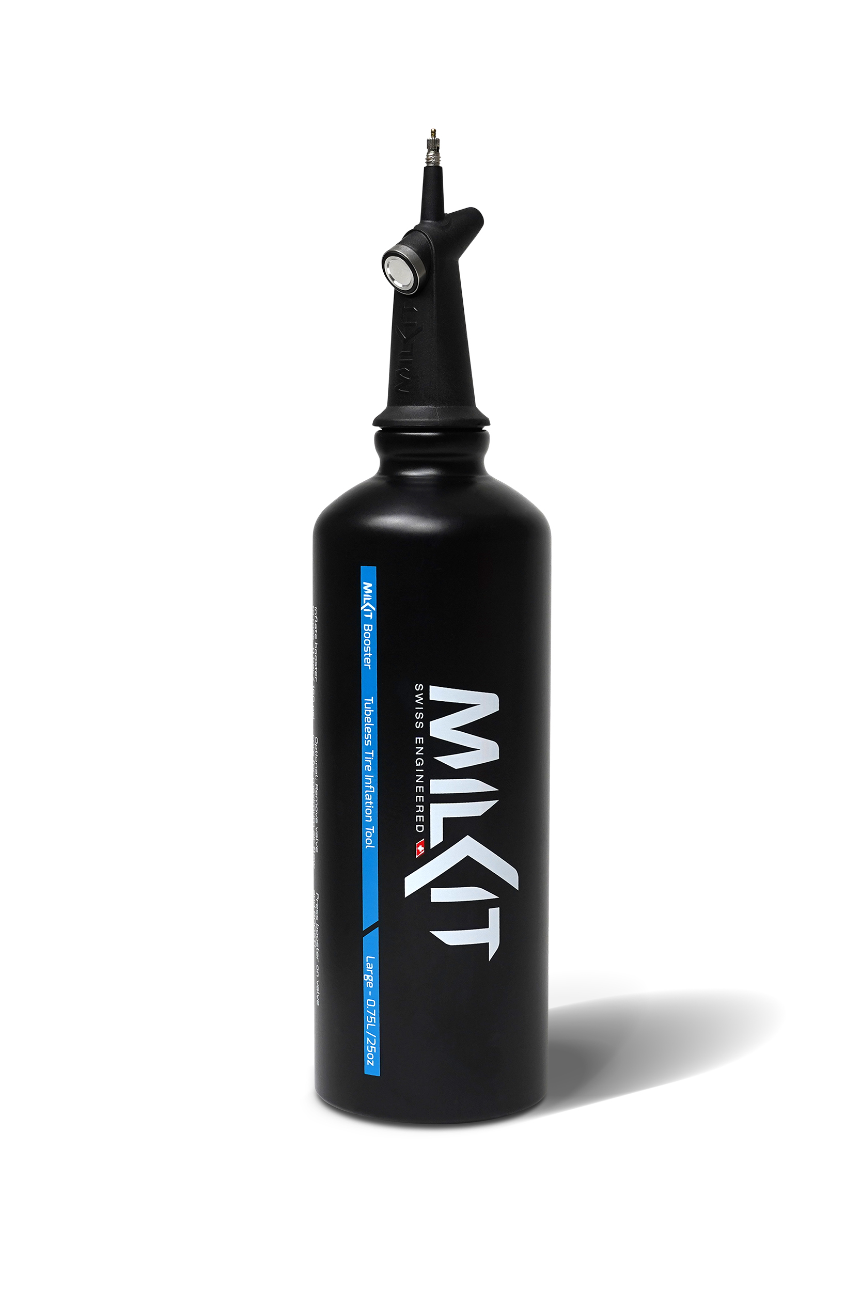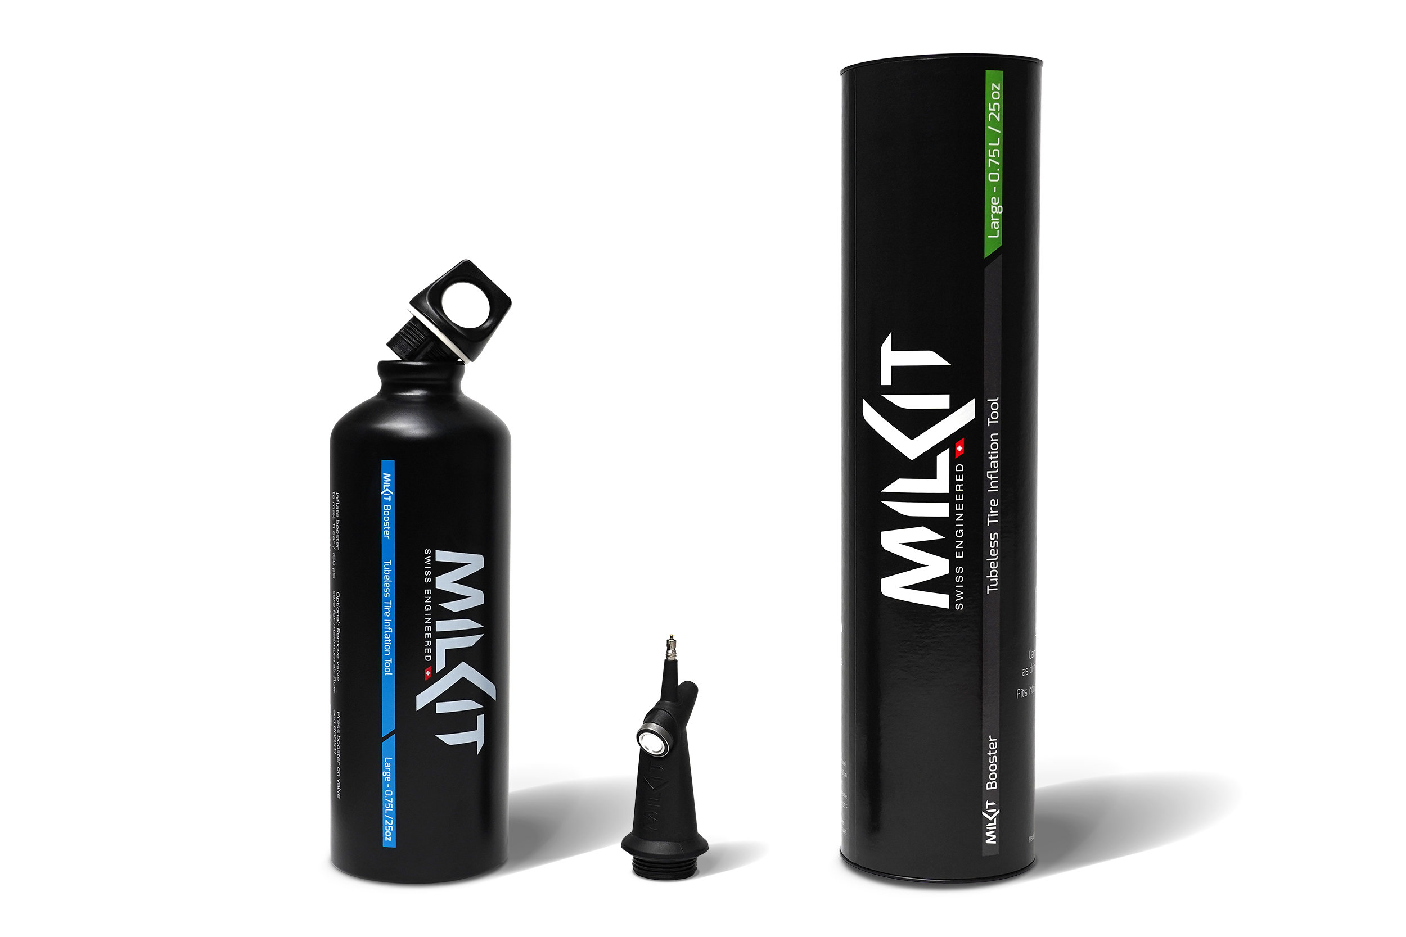

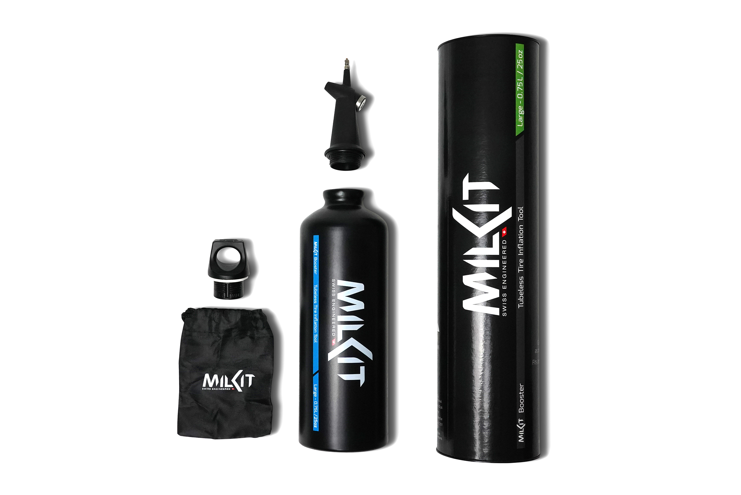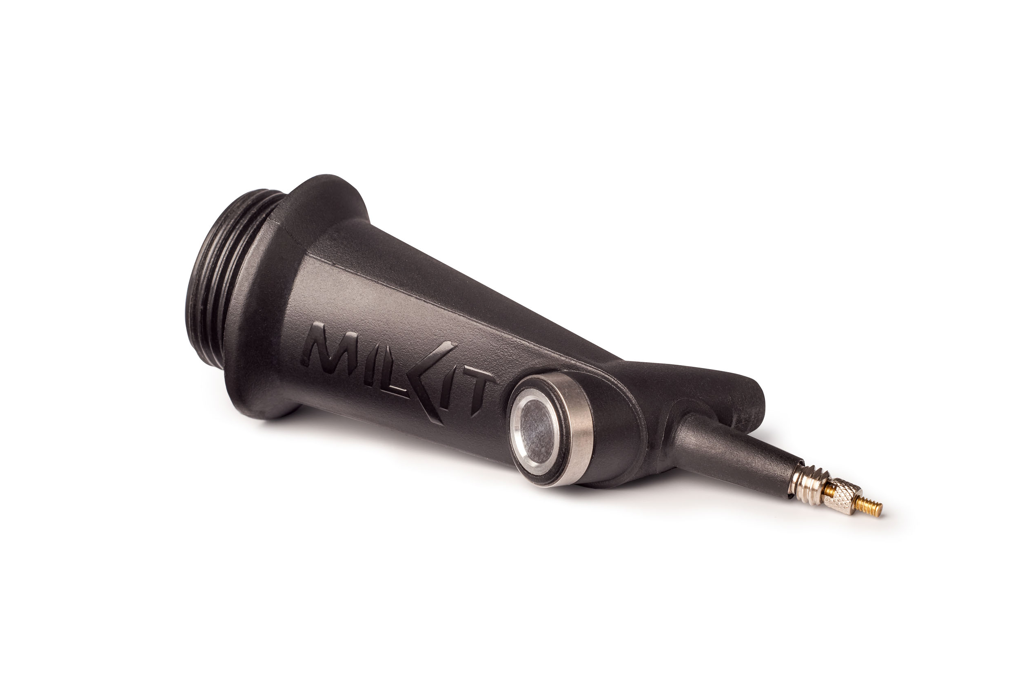

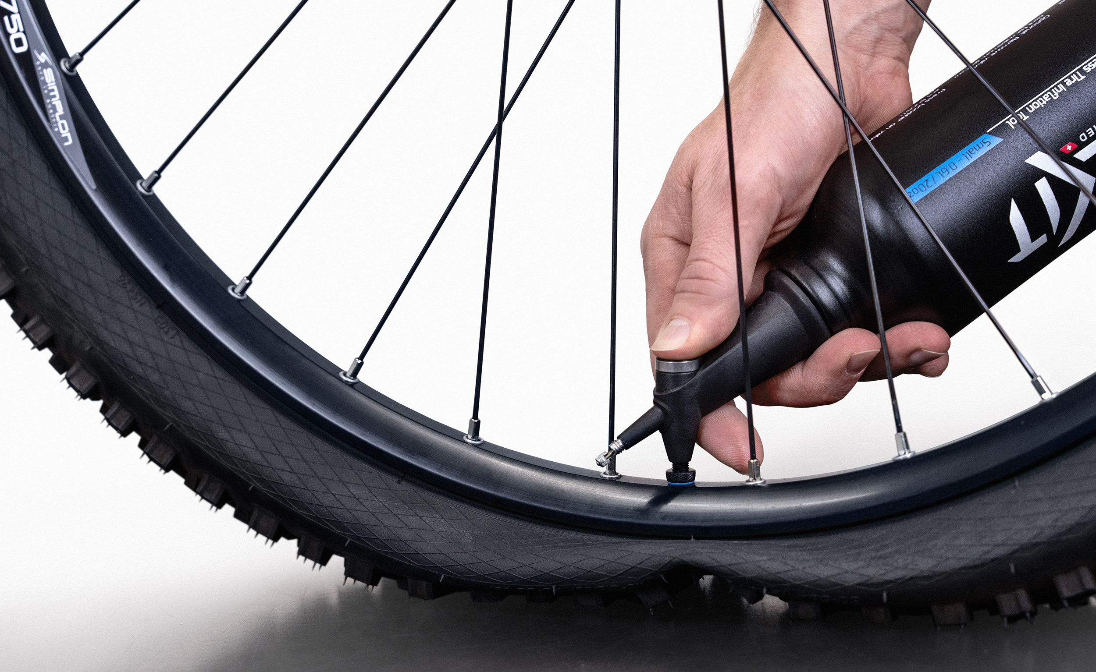

More pictures in high resolution: www.milKit.bike/media

