Text Online-Shops EN: General milKit introduction and explanation text (for milKit brand sites)

Tubeless tire set-up without the worries, the mess and the clogged-up valves
milKit makes tubeless conversion a breeze! This is your one stop shop for converting your mountain bike or road bike to tubeless tires. Running a tubeless set up has many advantages: it is lighter, more resistant to pinch flats, has better traction and avoids ride stopping punctures from thorns and sharp stones. However, before milKit revolutionized tubeless mounting, getting your wheels set up was a long messy job. Checking sealant levels was equally tiresome, so many riders ran the risk of riding without sealant as checks meant more mess!
milKit has made this easy:
- Install rim tape
- Install milKit valves and screw out the milKit valve core
- Pre-inflate your tire up to 22 psi (we recommend the milKit Booster) - the rubber valve flaps ensure no air is lost even without the valve core installed
- Measure out the correct amount of sealant and insert into pressurized tire using the syringe: mess-free!
- Screw the valve core back in and inflate the tire to full riding pressure - the tire now jumps onto the rim fully. You’re ready to ride!
Ongoing maintenance is also easy. With other tubeless tire systems you need to remove the tire to check if enough sealant remains, with milKit you can simply remove the valve core and insert the syringe to check. No mess and faster results!
Rubber flaps at the bottom of the valve prevent sealant from filling and blocking the valve, as well as ensuring no air is lost when the core is removed.
The syringe holds 60ml or 2 oz of fluid and comes with a flexible connector and a large needle to push through the valve and rubber flaps. There’s also a sealant regulator that screws into the syringe for easy refilling. The needle has an angled end for effective removal of all sealant in the tire, so you know exactly how much sealant is in there.
Swiss-engineered and made in Germany, the product is convincing because of its high-quality and lightweight aluminium valves as well as the elegant design with intelligent detailing.
The valves fit into all common rims, including that of road, gravel and MTB tubeless wheels.
More information and videos can be found on www.milKit.bike

Pictures of the milKit product world

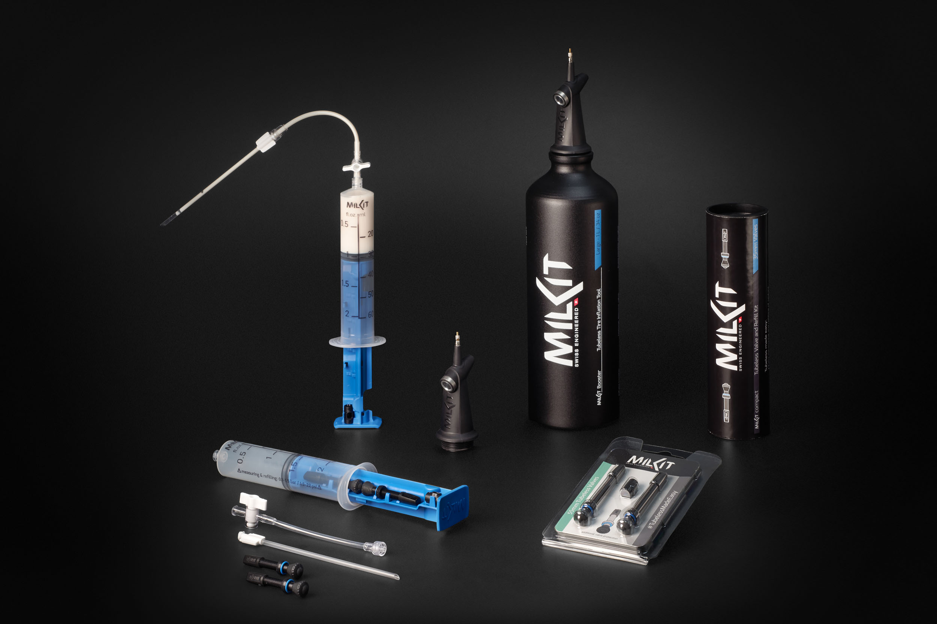

More pictures in high resolution: www.milKit.bike/media

