Text Online-Shops EN: milKit Rim Tape

Your strong and reliable tubeless rim tape
milKit rim tape offers quick and easy conversion of your rim to tubeless and guarantees a reliable and long-lasting performance
- Available in the four most popular widths - covering most rim sizes
- Extra strong and reliable adhesive to ensure a tight fit on your rim
- Optimum mix of strength and flex for easy mounting
- 10m/11yd rolls - sufficient to set up 4-5 wheels
milKit products offer the simplest solution for tubeless installation and maintenance. We designed our rim tape to be very strong and reliable for an airtight fit, but with enough flex to make installation quick and easy.
Choose a rim tape width that matches the inner width of your rim or is slightly larger. The rim tape should cover the whole rim base and it can even cover a part of both sides. Using too narrow rim tape can lead to air leaking between rim and tape - which can be frustrating. If it is too wide it can interfere with the tire seating correctly.
For easy and effective installation:
- Clean rim thoroughly and ensure it is dry
- Install rim tape by pulling it firmly into the rim. It must be tight and ensure there are no gaps or air trapped underneath.
- Make sure it overlaps at least 10 cm / 4 in over the valve hole, it's better to have a longer overlap than shorter
- Use two layers for high pressure wheels (above 8 bar / 120 psi)
- Cut rim tape at a 45° angle for the best adhesion and flexibility
- Install milKit tubeless valves into rim: pinch just a small hole into the rim tape and push valve through tape into rim
More information and videos can be found on www.milKit.bike

Pictures of the milKit Rim Tape

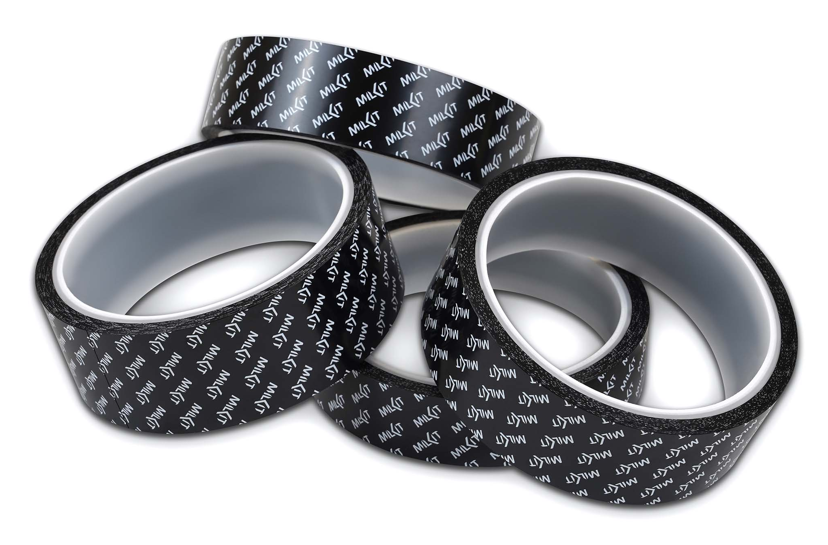

More pictures in high resolution: www.milKit.bike/media

