Text Online-Shops EN: milKit Tubeless Conversion Kit

Tubeless tire set-up without the worries, the mess and the clogged-up valves
milKit makes tubeless conversion a breeze! This is your one stop shop for converting your mountain bike or road bike to tubeless tires.
The smart milKit valves with additional rubber flaps don't get clogged by sealant anymore and you can measure and refill sealant in your tire without having to release the air pressure:
- Install rim tape
- Install milKit valves and screw out the milKit valve core
- Pre-inflate your tire up to 22 psi (we recommend the milKit Booster) - the rubber valve flaps ensure no air is lost even without the valve core installed
- Measure out the correct amount of sealant and insert into pressurized tire using the syringe: mess-free!
- Screw the valve core back in and inflate the tire to full riding pressure - the tire now jumps onto the rim fully. You’re ready to ride!
The syringe holds 60ml or 2 oz of fluid and comes with a flexible connector and a large needle to push through the valve and rubber flaps. There’s also a sealant regulator that screws into the syringe for easy refilling. The needle has an angled end for effective removal of all sealant in the tire, so you know exactly how much sealant is in there.
Swiss-engineered and made in Germany, the product is convincing because of its high-quality and lightweight aluminium valves as well as the elegant design with intelligent detailing.
The valves fit into all common rims, including that of road, gravel and MTB tubeless wheels.
More information and videos can be found on www.milKit.bike
A milKit Tubeless Conversion Kit contains the following:
- 1x milKit sealant bottle 250 ml / 8 oz
- 1x milKit compact syringe system
- 2x 45 mm milKit tubeless valves
- 1x 10 m tubeless rim tape
- 1x additional needle for syringe filling
- 1x valve core tool

Pictures of the milKit Tubeless Conversion Kit
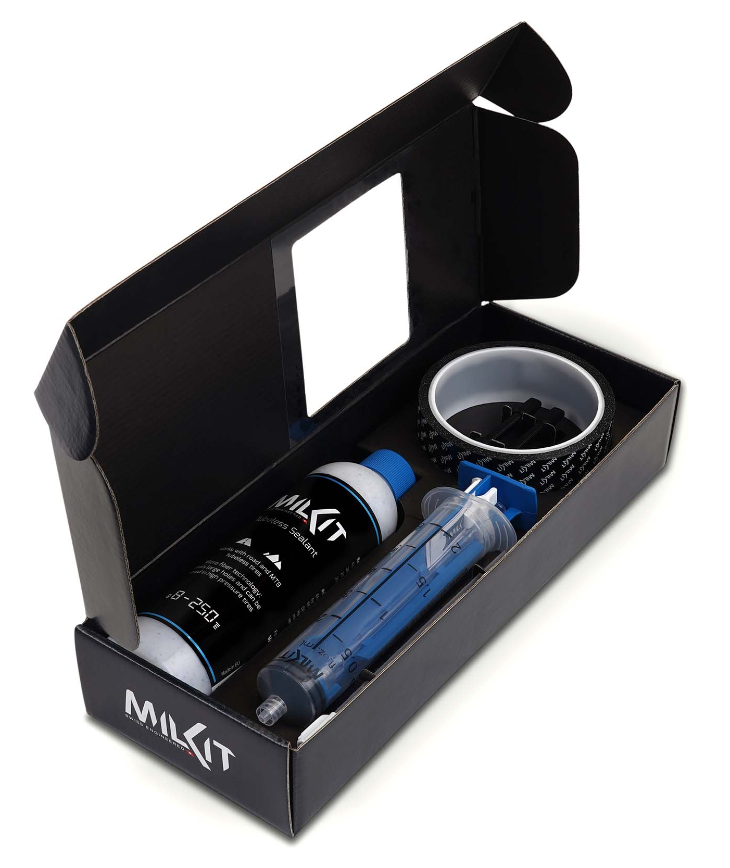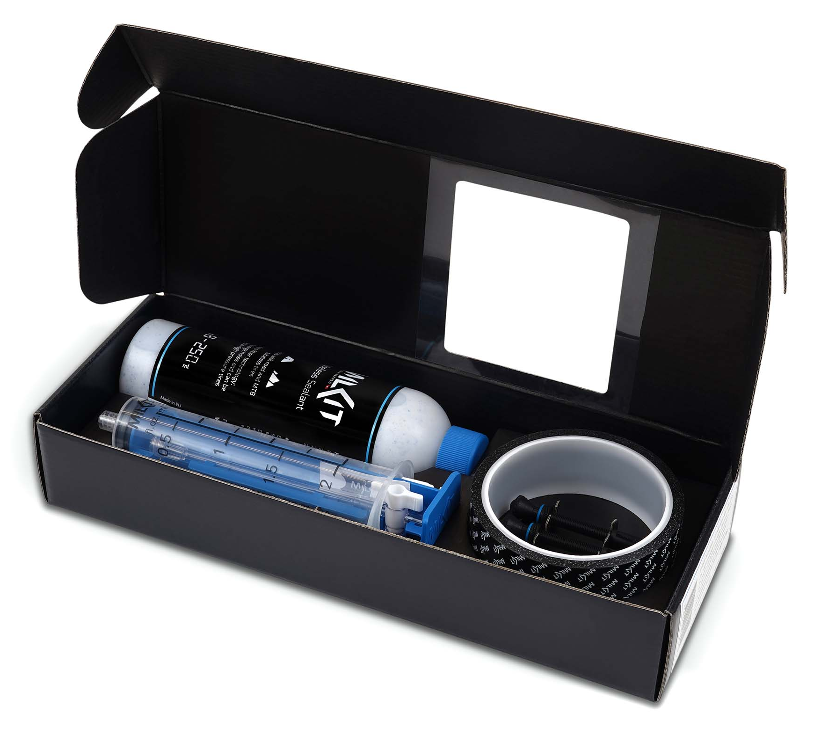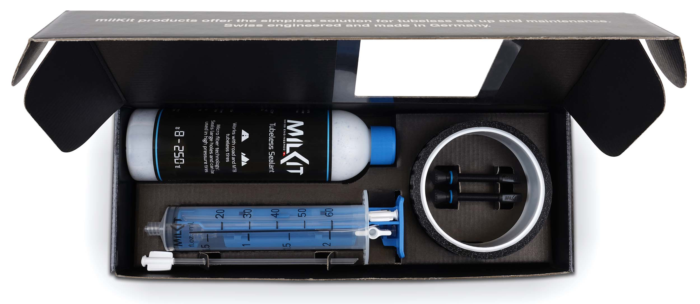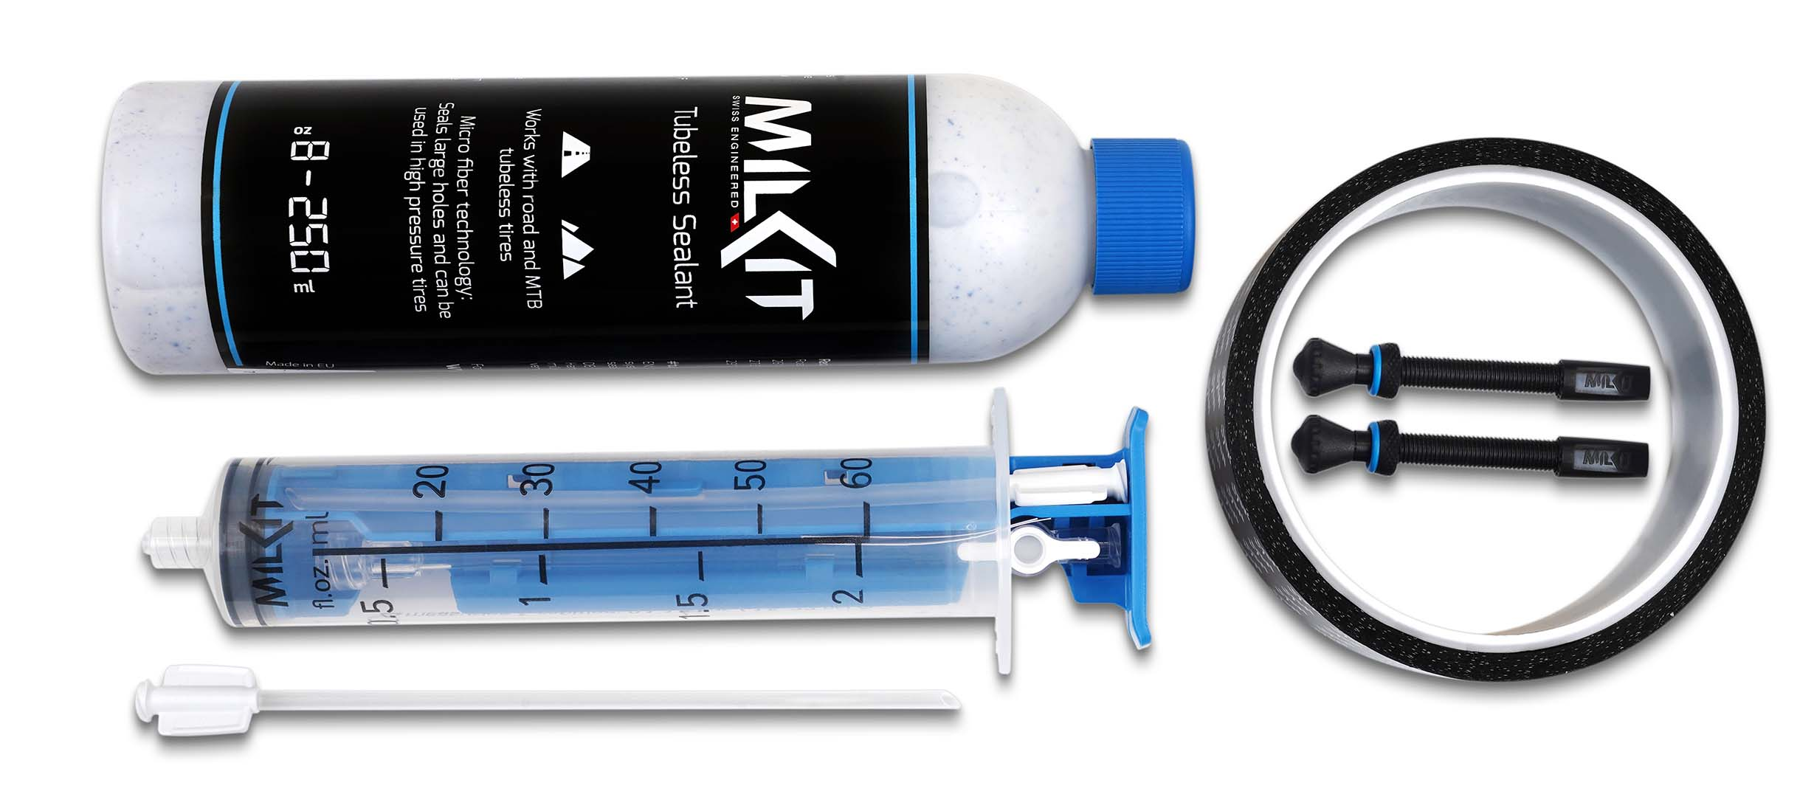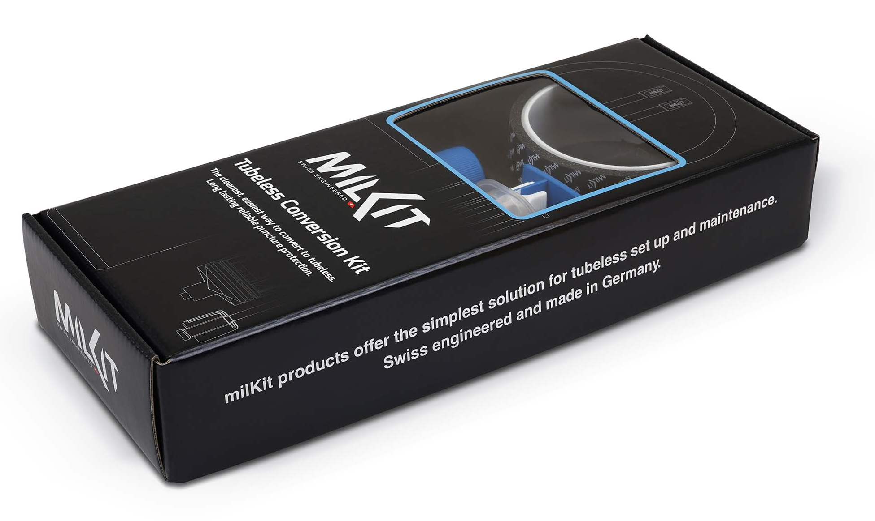

More pictures in high resolution: www.milKit.bike/media

